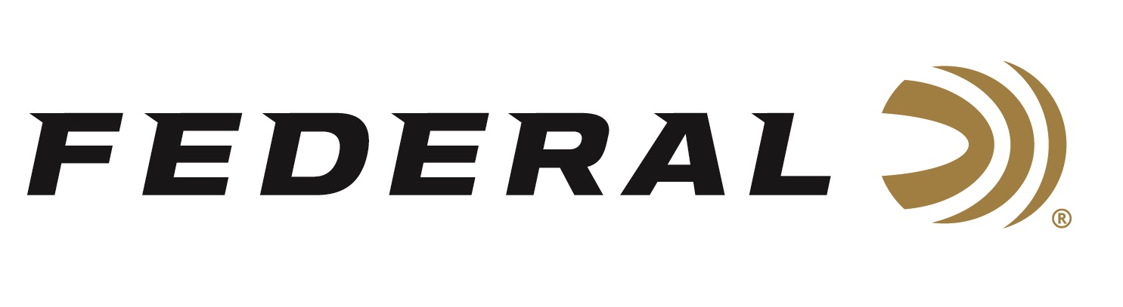

FOR IMMEDIATE RELEASE
Federal’s New 6mm ARC Gold Medal Berger Target Load Now Shipping
ANOKA, Minnesota – December 17, 2025 – Federal Ammunition has officially begun shipping a new load in its award-winning Gold Medal® Berger® lineup: 6mm ARC, 108-grain Berger BT Target. Precision rifle competitors and long-range shooters can now get this sought-after bullet loaded into the industry’s most trusted factory rifle ammunition from Federal. Proven performance and accuracy from the production line to the benchrest, where precision matters most.
Gold Medal Berger 6mm ARC Ammo | 108 Grain, 2650 FPS
“The 6mm ARC continues to prove itself in the hands of competitive shooters and pairing it with the industry’s most sought-after Berger Target bullets takes it to the next level,” said Mike Holm, Federal’s Director of Centerfire Rifle Ammunition. “This load gives PRS competitors and precision shooters the ballistic efficiency and reliable consistency they demand—right out of the box.”
Federal’s Gold Medal Berger loads feature an advanced boat-tail bullet with an extremely high ballistic coefficient to provide the flattest trajectories, less wind drift, and pinpoint accuracy at long ranges. They’re loaded with Gold Medal match primers, Federal® brass, and specially formulated propellant. Like all Gold Medal offerings, these cartridges are held to Federal Premium’s strictest specifications for accuracy, pressure, and velocity.
Part No. / Description / MSRP
GM6ARCCBT1 / 6mm ARC, 108-grain Berger BT Target / 20 Round-Box/ $39.99
Federal Ammunition products are available at dealers nationwide and online. For more information on all Federal products and to sign up to receive notifications about new product availability, rebate promotions, and other brand news via email, visit www.federalpremium.com.

Press Release Contact: JJ Reich
Senior Manager – Press Relations
E-mail: media@tkghunt.com
About Federal Ammunition
Federal, headquartered in Anoka, MN, is an ammunition brand of The Kinetic Group, owned by CSG, a globally diversified industrial group based in Prague, Czech Republic. Since 1922, Federal has been a leader in ammunition innovation, delivering high-quality sporting and hunting products to shooters worldwide. With a commitment to conservation and the outdoor community, Federal continues to manufacture industry-leading ammunition that enhances the shooting experience while supporting outdoor traditions.

