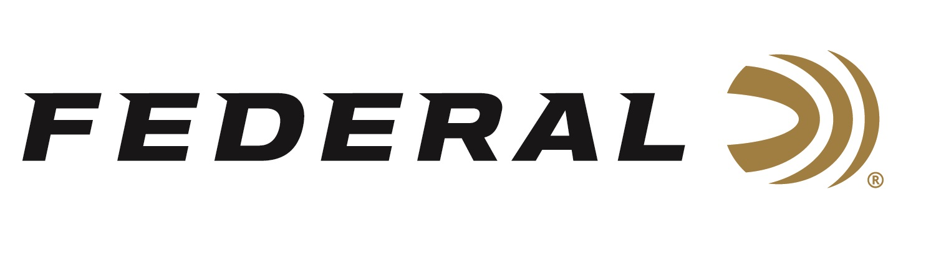

FOR IMMEDIATE RELEASE

**Federal’s New Personal Defense HST 44 Rem. Mag Now Shipping**

**ANOKA, Minnesota – June 12, 2025 –** Federal Ammunition has recently added a new HST 44 Rem. Mag. “Light Magnum” load featuring a specially designed hollow-point bullet, added to the Federal Premium Personal Defense product line. The new product is ideal for those seeking HST performance for self-defense with magnum revolvers. The latest load is currently being delivered to retailers nationwide.

[Personal Defense HST, 44 Rem Magnum, 230 Grain, Jacketed Hollow Point](https://www.federalpremium.com/handgun/personal-defense-hst/11-P44HST1S.html)

“This new HST loading addresses customer requests for a Personal Defense® option in 44 Mag, offering more power than a 44 Special load but better control and less overpenetration than a full-magnum hunting load,” said Chris Laack, Federal Handgun Ammunition Product Manager. “Its cartridge-specific bullet design best utilizes the magnum power available for defense and has more energy than 10mm Auto and 357 Mag yet with a larger 44 Mag projectile. It is incredible.”

Features and benefits also include an expanded diameter and weight retention, which produce the desired penetration for self-defense situations without over-penetration. Additionally, it exhibits superior performance in terminal ballistics testing used by law enforcement. The nickel-plated case and high-performance sealed primer provide ultimate reliability. The product is sold in 20-count boxes.

“When matched with the HST bullet design, the 44 Magnum provides the energy to achieve both effective penetration depth and significant hollow-point expansion,” continued Laack. “This HST does exactly what a great hollow-point bullet should. It provides significant expansion and retained weight while achieving optimized penetration depths in tissue with reduced risk for over-penetration.”

**Part No. / Description / MSRP**

P44HST1S / 44 Rem Magnum, 230 Grain, HST Hollow-Point, 1,085 fps / $55.99

Federal Ammunition products are available at dealers nationwide and online. For more information on all Federal products and to sign up to receive notifications about new product availability, rebate promotions, and other brand news via email, visit [www.federalpremium.com](http://www.federalpremium.com).

**Press Release Contact:**  
JJ Reich  
Senior Manager – Press Relations  
E-mail: [media@tkghunt.com](mailto:media@tkghunt.com)

**About Federal Ammunition**

Federal, headquartered in Anoka, MN, is an ammunition brand of The Kinetic Group, owned by CSG, a globally diversified industrial group based in Prague, Czech Republic. Since 1922, Federal has been a leader in ammunition innovation, delivering high-quality sporting and hunting products to shooters worldwide. With a commitment to conservation and the outdoor community, Federal continues to manufacture industry-leading ammunition that enhances the shooting experience while supporting outdoor traditions.