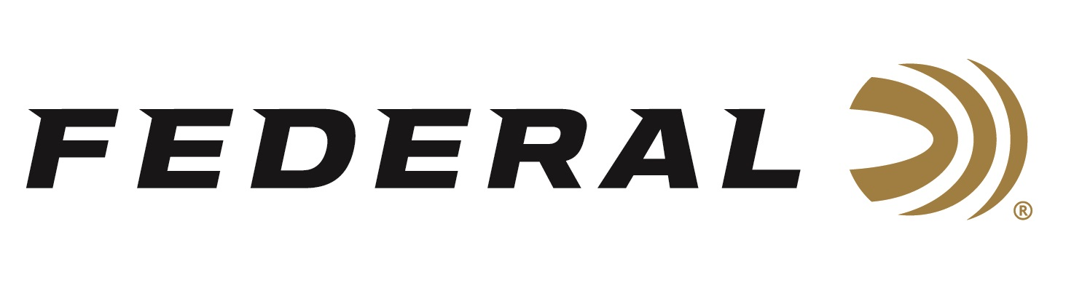

FOR IMMEDIATE RELEASE

**Federal Ammunition’s New HammerDown 22 LR Hunting Rounds Available at Retailers**

**ANOKA, Minnesota – February 13, 2025 –** Federal Ammunition recently released Its all-new HammerDown 22 LR rimfire product line and is currently being delivered to retailers nationwide.

The New 22 LR hunting round features nickel-plated brass for weather and corrosion resistance, specially formulated propellant, and a copper-plated hollow-point bullet. It is loaded to velocities that provide superior ballistics through lever-action rimfire rifles and delivers excellent cycling in tubular-magazine and lever-action feeding systems. It is packaged in 325-round bulk boxes.

[HammerDown Rimfire 22 LR Ammo](https://www.federalpremium.com/rimfire/hammerdown-rimfire/11-22HAM.html)

“The technology that revitalized centerfire lever-action rifles and carbines is now available for rimfire,” said CCI’s Rimfire Product Line Manager Steve Monniere. “Our new HammerDown Rimfire 22 LR load features a specially modified copper-plated hollow point bullet designed to function flawlessly in all lever guns and modern sporting rifles (MSRs). The new bullet’s hollow-point design offers excellent expansion at hunting ranges between 25 to 100 yards for small game.”

**Part No. / Description / MSRP**

22HAM / 22 LR, 40-grian, Copper-plated HP 325-count, 1,200 fps / $39.99

Federal Ammunition products are available at dealers nationwide and online. For more information on all Federal products, visit [www.federalpremium.com](http://www.federalpremium.com).

**Press Release Contact:** JJ Reich

Senior Manager – Press Relations

E-mail: media@tkghunt.com

**About Federal Ammunition**

Federal, headquartered in Anoka, MN, is an ammunition brand of The Kinetic Group, owned by CSG, a globally diversified industrial group based in Prague (Czech Republic). From humble beginnings nestled among the lakes and woods of Minnesota, Federal Ammunition has evolved into one of the world's largest producers of sporting ammunition. In 1922, founding President Charles L. Horn paved the way for our success. Today, Federal carries on Horn's vision for quality products and services with the next generation of outdoorsmen and women. We maintain our position as experts in the science of ammunition production. Every day, Federal manufactures products to enhance our customers' shooting experience while partnering with the conservation organizations that protect and support our outdoor heritage. Federal offers thousands of options in our Federal Premium® and standard Federal® lines, which is what makes it the most complete ammunition company in the business and helps it provide customers with a choice no matter what the pursuit.