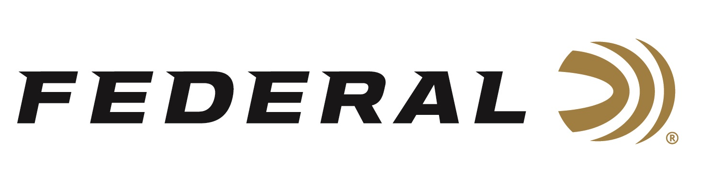

FOR IMMEDIATE RELEASE

**Federal Sponsored Shooter Vincent Hancock Collects Two Gold Medals in Athens, Greece**

**ANOKA, Minnesota – October 15, 2025 –** Federal Ammunition congratulates sponsored shooter Vincent Hancock, a four-time Olympic champion, on bringing home two more World Championship gold medals in Men’s Skeet from the 2025 ISSF World Shotgun Championship. The competition is being held at the Malacasa shooting range in Athens, Greece, from October 8 through 19, 2025.

At the event, Hancock won his fifth individual men's skeet world title. His victory was part of a dominant performance by the USA Shooting team, which swept the individual skeet titles. Hancock hit 59 out of 60 targets in the final, finishing four points ahead of the silver medalist, and he topped the qualification standings by missing just one target, scoring 124 out of 125.

In the Men’s Team Skeet competition, Hancock and his teammates Connor Prince and Christian Elliot won the gold medal match. Hancock continued his perfection in the finals, which helped him secure his second gold medal at the event. That performance also helped the U.S.A. dominate the ISSF World Shotgun Championship overall.

“These gold medals further cement Hancock's status as one of the sport's greatest athletes,” said Jason Nash, Federal’s Vice President of Marketing. “This victory adds to Hancock's extensive list of accomplishments, including four Olympic gold medals. We, at Federal, always look forward to seeing more continued success and his outstanding international performances.”

Federal Ammunition recently launched an all-new shotshell product line: Federal All-American. These competition-level target loads use a Podium wad that’s customized for straight-wall hulls. The design’s exclusive compression zone cushions the payload at ignition, resulting in better patterns and softer shooting. All-American’s high-antimony lead shot is pushed by quality propellant and primers to crush the most challenging targets in high-level Trap and Skeet shooting.

Learn more at: [All-American | Federal Premium](https://www.federalpremium.com/shotshell/all-american/)

Federal Ammunition products are available at dealers nationwide and online. For more information on all Federal products and to sign up to receive notifications about new product availability, rebate promotions, and other brand news via email, visit [www.federalpremium.com](http://www.federalpremium.com).

**Press Release Contact:** JJ Reich  
Senior Manager – Press Relations  
E-mail: [media@tkghunt.com](mailto:media@tkghunt.com)

**About Federal Ammunition**

Federal, headquartered in Anoka, MN, is an ammunition brand of The Kinetic Group, owned by CSG, a globally diversified industrial group based in Prague, Czech Republic. Since 1922, Federal has been a leader in ammunition innovation, delivering high-quality sporting and hunting products to shooters worldwide. With a commitment to conservation and the outdoor community, Federal continues to manufacture industry-leading ammunition that enhances the shooting experience while supporting outdoor traditions.