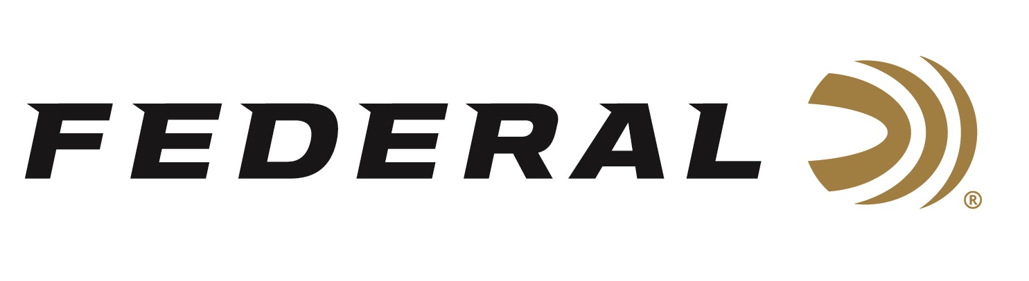

FOR IMMEDIATE RELEASE

Federal Ammunition Sponsored Shooter Vincent Hancock Takes Silver at the ISSF World Cup in Qatar

ANOKA, Minnesota – December 11, 2025 – Federal Ammunition congratulates Vincent Hancock on his excellent performance in Men’s Skeet at the ISSF World Cup
Final in Doha, Qatar, held December 4-9.

Hancock, ranked number 2nd in the world, shot his way into the Men’s Skeet finals in the first position by shooting a perfect 125 during qualification. In the Final, Hancock finished 2nd in the tournament, earning a World Cup Final silver medal. He was bested by fellow American Elliot Christian, a representative of the U.S. Army, by just one target.

“Federal Ammunition is extremely proud of the performance turned in by Hancock all year long,” said Jason Nash, Federal’s V.P. of Marketing. “Vincent is a 4-time Olympic gold medalist, and he consistently sets the gold standard when it comes to competing on the world stage in Men’s Skeet. With the end of the calendar year fast approaching, we are already looking forward to more high-level performances from him and all our shooters on Team Federal.”

Federal is the number one choice for shotgun shells. The company manufactures products in America for all competitive and recreational disciplines. See the full lineup, including Master Class and All-American target loads, at www.federalpremium.com.

New in 2026, Federal will also offer All-American target loads in shot size No. 9 that will be popular with Skeet shooters. The latest and greatest All-American product line consists of twelve competition Trap loads that use Federal’s own Podium™ wad that’s customized for straight-wall hulls.

Federal Ammunition products are available at dealers nationwide and online. For more information on all Federal products and to sign up for notifications about new product availability, rebate promotions, and other brand news via email, visit www.federalpremium.com.

Press Release Contact: JJ Reich
Senior Manager – Press Relations
E-mail: media@tkghunt.com

About Federal Ammunition
Federal, headquartered in Anoka, MN, is an ammunition brand of The Kinetic Group, owned by CSG, a globally diversified industrial group based in Prague, Czech Republic. Since 1922, Federal has been a leader in ammunition innovation, delivering high-quality sporting and hunting products to shooters worldwide. With a commitment to conservation and the outdoor community, Federal continues to manufacture industry-leading ammunition that enhances the shooting experience while supporting outdoor traditions.

