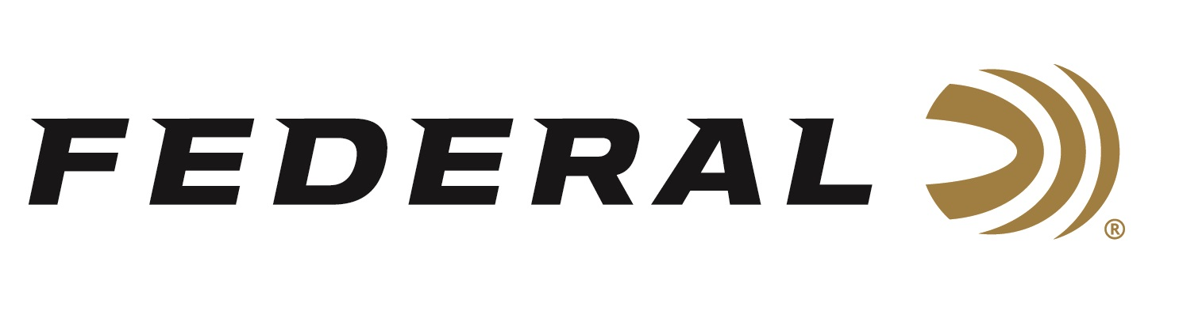

FOR IMMEDIATE RELEASE

**Federal’s New Hydra-Shok Deep 32 H&R and 45 Colt Loads**

**Now Shipping**

**ANOKA, Minnesota – April 14, 2025 –** Federal Ammunition recently added new 32 H&R and 45 Long Colt cartridges to its Hydra-Shok Deep product line. The new Personal Defense loads feature cartridge-optimized, controlled-expansion projectiles that provide the perfect balance between expansion size and penetration depth. These new products are currently being delivered to retailers nationwide.

[Personal Defense Hydra-Shok Deep](https://www.federalpremium.com/handgun/personal-defense-hydra-shok-deep/?prefn1=caliber&prefv1=32%20H%26R%20Magnum%7C45%20Colt)

“These new products address the need for modernized defensive ammunition for popular .45 Colt revolvers and rifles, as well as requests for a modern defense bullet in .32 H&R,” said Chris Laack, Federal Handgun Ammunition Product Manager. “Both of the different and unique bullet designs for these two new loads achieve critical penetration depths through barriers encountered in self-defense situations.”

Federal Premium Hydra-Shok has proven itself for self-defense since 1989. The Hydra-Shok Deep Jacketed Hollow Point (JSP) builds upon that time-tested platform with design improvements that better meet modern performance standards. The bullet features a more robust center post and a core design that penetrates to optimal depths through the most common barriers encountered in self-defense situations.

“Our Hydra-Shok Deep bullet for the 45 Colt is designed and optimized to work within the limitations of the 45 Colt, from short revolvers to full-length carbine rifles,” continued Laack. “Our Hydra-Shok Deep bullet for 32 H&R supports the launch of several new guns in that cartridge as well as offering a lower recoil option in 327 Federal Magnum chambered revolvers.”

The new Personal Defense loads feature the iconic center post bullet design, which has been improved for better, more consistent expansion. They also include specially formulated propellant, an extremely reliable, high-performance sealed primer, and Federal Premium nickel-plated cases. Both are sold in 20-count boxes.

**Part No. / Description / MSRP**

P32HRHSD1 / 32 H&R Magnum, 85-grain, Hydra-Shok Deep JSP, 1,025 fps / $38.99

P45CHSD1 / 45 Colt, 210-grain, Hydra-Shok Deep JSP, 913 fps / $44.99

Federal Ammunition products are available at dealers nationwide and online. For more information on all Federal products, visit [www.federalpremium.com](http://www.federalpremium.com).

**Press Release Contact:** JJ Reich

Senior Manager – Press Relations

E-mail: media@tkghunt.com

**About Federal Ammunition**

Federal, headquartered in Anoka, MN, is an ammunition brand of The Kinetic Group, owned by CSG, a globally diversified industrial group based in Prague (Czech Republic). From humble beginnings nestled among the lakes and woods of Minnesota, Federal Ammunition has evolved into one of the world's largest producers of sporting ammunition. In 1922, founding President Charles L. Horn paved the way for our success. Today, Federal carries on Horn's vision for quality products and services with the next generation of outdoorsmen and women. We maintain our position as experts in the science of ammunition production. Every day, Federal manufactures products to enhance our customers' shooting experience while partnering with the conservation organizations that protect and support our outdoor heritage. Federal offers thousands of options in our Federal Premium® and standard Federal® lines, making it the most complete ammunition company in the business and helping it provide customers with a choice no matter what the pursuit.