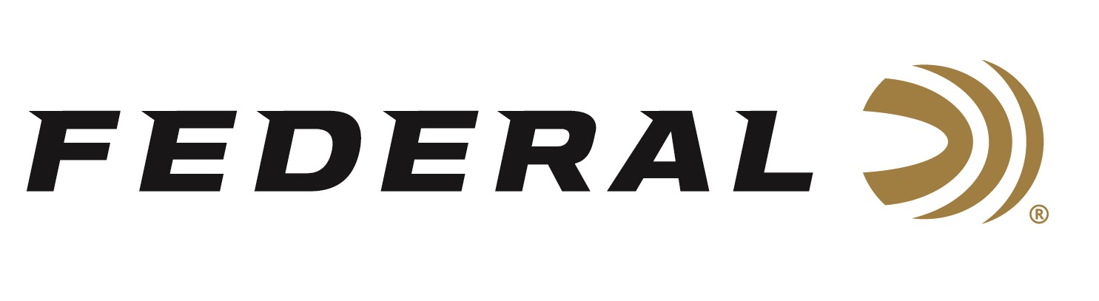

FOR IMMEDIATE RELEASE

Federal Ammunition’s Derrick Mein Earns a Spot on the NSCA FITASC Senior Team

ANOKA, Minnesota – November 19, 2025 – The National Sporting Clays Association (NSCA) has recently announced its 2026 USA Sporting Clays Team members, selected based on points earned during the 2025 season. Federal Ammunition congratulates sponsored shooter Derrick Mein for earning his spot on the 2026 FITASC Senior Team.

“It’s an honor to get the opportunity to represent the USA at a world championship as a part of our national team,” said Derrick Mein. “I wouldn’t be able to achieve such a position without the quality and reliability of my Federal Premium® Gold Medal Papers I use for competition. I feel like they give me a competitive advantage every time I’m out on the course.”

The 2026 USA Sporting Clays Team members are American citizens who will represent the association and the country in international competitions. Qualifying for a position on the USA Sporting Clays Team is based on points earned at a shooter’s top four USA Sporting Clays Team selection shoots. The team represents the United States in international competitions, and selection criteria include a minimum number of targets shot during the previous year, based on category. The final team roster for 2026 was recently confirmed on the NSCA's social media channels.

“Congratulations to Derrick, who is a talented shooter and has dedicated countless hours and competed at the highest level throughout the season to earn his place on this prestigious team,” said Jason Nash, Federal Ammunition’s Vice President of Marketing. “We're incredibly proud of this accomplishment and his representation of our brand and products. We are looking forward to seeing him represent the USA next year.”

Federal is the number one choice for shotgun shells and manufactures products in America for all competitive and recreational disciplines. See the full lineup, including the latest Master Class, at www.federalpremium.com.

Federal Ammunition products are available at dealers nationwide and online. For more information on all Federal products and to sign up for notifications about new product availability, rebate promotions, and other brand news via email, visit www.federalpremium.com.
Press Release Contact: JJ Reich
Senior Manager – Press Relations
E-mail: media@tkghunt.com

About Federal Ammunition
Federal, headquartered in Anoka, MN, is an ammunition brand of The Kinetic Group, owned by CSG, a globally diversified industrial group based in Prague, Czech Republic. Since 1922, Federal has been a leader in ammunition innovation, delivering high-quality sporting and hunting products to shooters worldwide. With a commitment to conservation and the outdoor community, Federal continues to manufacture industry-leading ammunition that enhances the shooting experience while supporting outdoor traditions.

