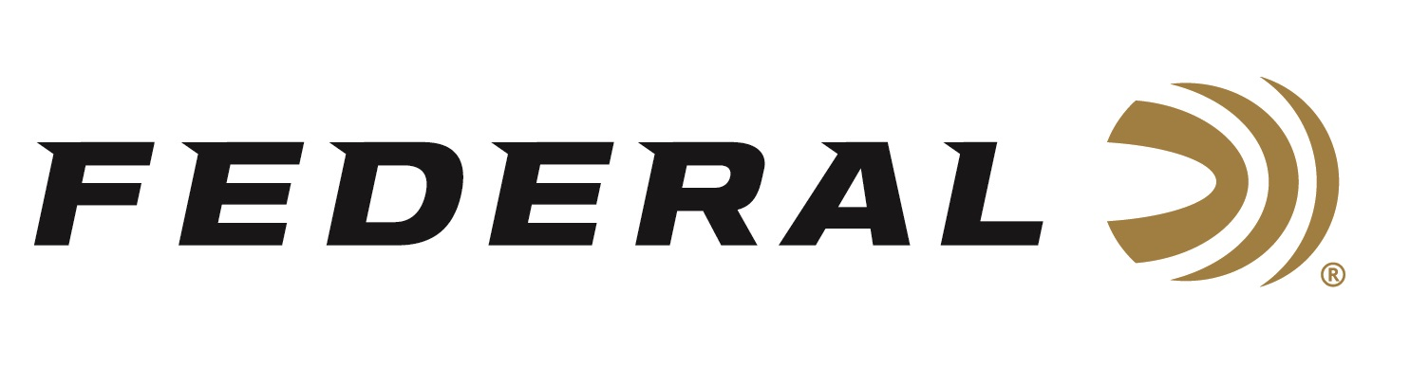

FOR IMMEDIATE RELEASE

**Federal’s Innovative 7mm Backcountry Cartridge Wins the Best Ammunition Caliber Award for 2025 by NASGW-POMA**

**ANOKA, Minnesota – October 16, 2025 –** Federal Ammunition’s new 7mm Backcountry cartridge has been presented with the Caliber Award in the Best Ammunition New Product category by the National Association of Sporting Goods Wholesalers (NASGW), in partnership with the Professional Outdoor Media Association (POMA). The Caliber Awards were recently announced during an appreciation dinner at the 2025 NASGW Expo, held October 15-17, in Grapevine, Texas.

“We know the Caliber Awards offer a balanced approach to recognizing and honoring new, innovative products. Judges were asked to consider the uniqueness, market need, the value of the product, ingenuity, and presentation," said Federal’s Vice President of Marketing Jason Nash. “Product innovation like this is a huge team effort. We thank our employees for making this product happen. We also thank all our industry partners, including customers, media partners, and firearm manufacturers who chamber rifles in this new cartridge. This is a great honor.”

The 9th Annual NASGW-POMA Caliber Awards honor the highest caliber new products in seven product categories, including the best new ammunition. The Caliber Awards are chosen by an independent panel of 18 industry professionals, encompassing hundreds of years of experience in the Shooting Sports Industry. The panel comprises wholesalers and media members who consistently stay on top of product trends and innovations.

Federal’s 7mm Backcountry is a new high-performance hunting cartridge boosted by all-new, patented one-piece, high-strength Peak Alloy case technology, which provides magnum performance in a standard bolt face rifle. Through 20-inch barrels and with 170-grain bullets, it can achieve 3,000 feet per second. Federal has recently published reloading data on its brand website’s product information page.

Learn more at: [Backcountry | Federal Premium](https://www.federalpremium.com/backcountry.html)

Federal Ammunition products are available at dealers nationwide and online. For more information on all Federal products and to sign up for notifications about new product availability, rebate promotions, and other brand news via email, visit [www.federalpremium.com](http://www.federalpremium.com).

**Press Release Contact:** JJ Reich  
Senior Manager – Press Relations  
E-mail: [media@tkghunt.com](mailto:media@tkghunt.com)

**About Federal Ammunition**

Federal, headquartered in Anoka, MN, is an ammunition brand of The Kinetic Group, owned by CSG, a globally diversified industrial group based in Prague, Czech Republic. Since 1922, Federal has been a leader in ammunition innovation, delivering high-quality sporting and hunting products to shooters worldwide. With a commitment to conservation and the outdoor community, Federal continues to manufacture industry-leading ammunition that enhances the shooting experience while supporting outdoor traditions.