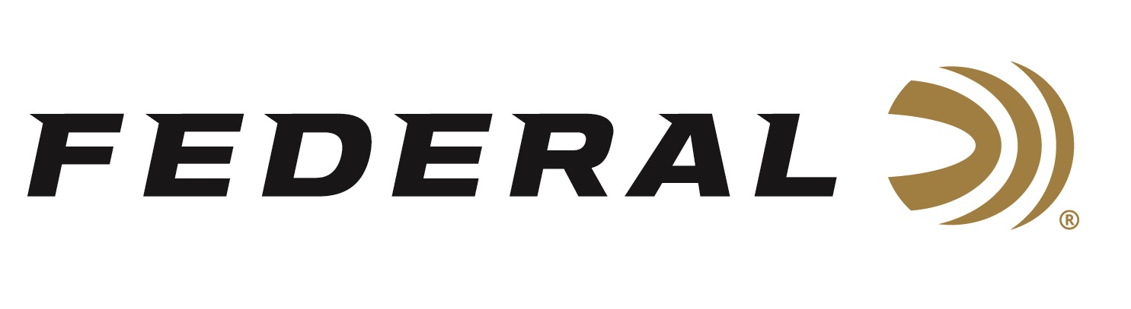

FOR IMMEDIATE RELEASE

Federal’s Innovative 7mm Backcountry Cartridge Awarded 2026
NRA American Hunter Golden Bullseye

ANOKA, Minnesota – December 19, 2025 – Federal’s 7mm Backcountry cartridge was recently awarded the 2026 Golden Bullseye Award from the NRA American Hunter publication for Product of the Year. Federal will be recognized and presented with the award during a special breakfast on Friday, April 17, 2026, at the 2026 NRA Annual Meetings & Exhibits in Houston, Texas.
“We are proud and grateful that the NRA American Hunter publication recognized the innovation with their Product of the Year award, because it speaks volumes for how legitimate the overall rifle cartridge design and purpose truly is,” said Federal’s Vice President of Product Development, Jesse Whiteside. “The 7mm Backcountry’s forward-thinking technology and design deserve the positive attention that has been given to it all year long. We look forward to continued progression in what modern ammunition can do with the Peak Alloy case. This award is additional proof that we are doing it right.”
Federal’s 7mm Backcountry is an all-new high-performance hunting cartridge boosted by all-new, patented one-piece, high-strength Peak Alloy case technology, which provides magnum performance in a standard bolt face rifle. Through 20-inch barrels and with 170-grain bullets, it can achieve 3,000 feet per second. The new cartridge is also intended for hunting with a suppressor, where shorter-barrel rifles are preferred.

Learn more at: Backcountry | Federal Premium.

The NRA Publications Golden Bullseye Awards acknowledge the finest products available for shooting sports. To qualify for consideration, a product must meet stringent criteria for design, function, value, and overall contribution to the shooting industry.

Federal Ammunition products are available at dealers nationwide and online. For more information on all Federal products and to sign up for notifications about new product availability, rebate promotions, and other brand news via email, visit www.federalpremium.com.

Press Release Contact: JJ Reich
Senior Manager – Press Relations
E-mail: media@tkghunt.com

About Federal Ammunition
Federal, headquartered in Anoka, MN, is an ammunition brand of The Kinetic Group, owned by CSG, a globally diversified industrial group based in Prague, Czech Republic. Since 1922, Federal has been a leader in ammunition innovation, delivering high-quality sporting and hunting products to shooters worldwide. With a commitment to conservation and the outdoor community, Federal continues to manufacture industry-leading ammunition that enhances the shooting experience while supporting outdoor traditions.

