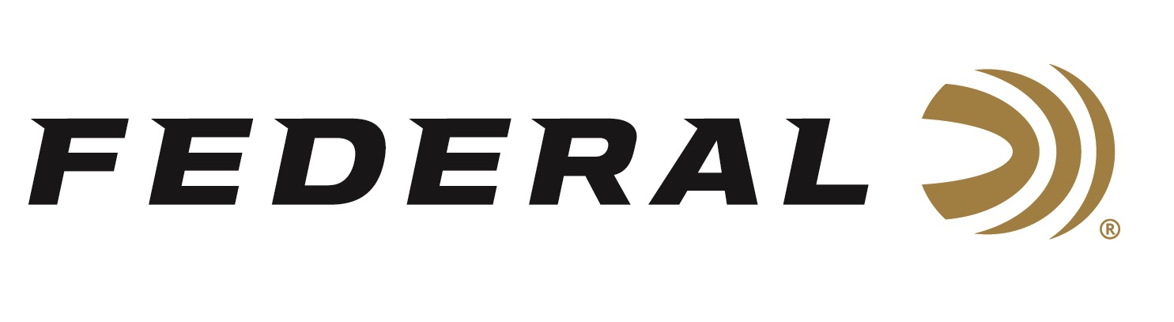

FOR IMMEDIATE RELEASE

On Target Magazine Honors Federal’s 7mm Backcountry Cartridge with Editors’ Choice Award

ANOKA, Minnesota – February 5, 2026 – On Target magazine recently honored Federal Ammunition’s 7mm Backcountry cartridge with a 2025 Editors’ Choice Award, as part of the magazine’s 24th annual awards program.

“These awards are reserved for the best-of-the-best new products which demonstrate outstanding technical achievement and/or represent an extraordinary value for the money,” said On Target Magazine Editor Ben Battles. “7mm Backcountry is engineered specifically for short-barreled hunting rifles, the kind of rifles that dominate steep remote country, and a notable benefit to the slimmer case design is increased magazine capacity. It is certainly an award-winning new product.”

On Target is one of the leading publications in the shooting sports industry. Its staff tests and reviews guns, ammunition, and hunting products, and presents the results in a straightforward, no-nonsense format that provides all the information consumers need to make purchase decisions. The print version of On Target can be picked up free at any of the nearly 2,000 firearm and hunting product retailers nationwide that distribute the magazine.

Federal’s 7mm Backcountry is an all-new high-performance hunting cartridge boosted by all-new, patented one-piece, high-strength Peak Alloy case technology, which provides magnum performance in a standard bolt face rifle. Through 20-inch barrels and with 170-grain bullets, it can achieve 3,000 feet per second. The new cartridge is also intended for hunting with a suppressor, where shorter-barrel rifles are preferred.

Learn more at: Backcountry | Federal Premium.

Federal Ammunition products are available at dealers nationwide and online. For more information on all Federal products and to sign up for notifications about new product availability, rebate promotions, and other brand news via email, visit www.federalpremium.com.

Press Release Contact: JJ Reich
Senior Manager – Press Relations
E-mail: media@tkghunt.com

About Federal Ammunition
Federal, headquartered in Anoka, MN, is an ammunition brand of The Kinetic Group, owned by CSG, a globally diversified industrial group based in Prague, Czech Republic. Since 1922, Federal has been a leader in ammunition innovation, delivering high-quality sporting and hunting products to shooters worldwide. With a commitment to conservation and the outdoor community, Federal continues to manufacture industry-leading ammunition that enhances the shooting experience while supporting outdoor traditions.

