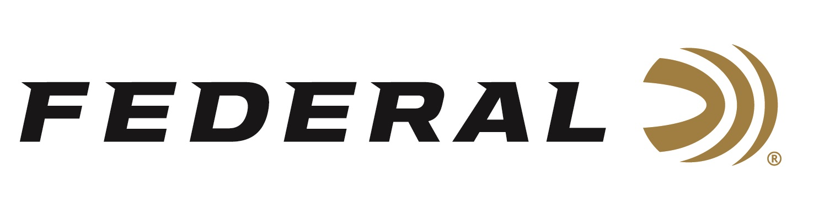

FOR IMMEDIATE RELEASE

**Federal Ammunition is the Presenting Sponsor for the 2025**

**Pheasant Fest & Quail Classic**

**ANOKA, Minnesota – February 26, 2025 –** The 2025 National Pheasant Fest and Quail Classic, presented by Federal Ammunition, will be held in Kansas City, Missouri,

March 7 - March 9 at the Kansas City Convention Center. The event will bring together tens of thousands of upland hunting enthusiasts to see all the best new products, including Federal Premium’s lineup of Pheasants Forever and Quail Forever branded product lines.

“Federal looks forward to seeing everyone in Kansas City and celebrating the outcomes of such strong conservation efforts that Pheasants Forever and Quail Forever have done over the last year,” said Jon Zinnel, Federal’s Director of Conservation. “We are also excited to celebrate Quail Forever’s 20th anniversary of protecting and enhancing quail habitat. In recent years, we’ve added the Quail Forever logo to several of our premium upland products to support their mission and add to the already branded Pheasants Forever product lines where the royalty goes back for mission support on the ground.”

Pheasant Fest & Quail Classic attendees are encouraged to stop by Federal’s booth No. 2426 to discuss the perfect ammunition for any upcoming hunting adventure with Federal's enthusiastic staff.

Federal Ammunition recently announced its expansion of options for upland hunting in 2025. These additions include new Federal Premium Upland Paper and Hi-Bird Fiber Wad loads and more.

Upland Paper will comprise six 2 3/4-inch 12- and 20-gauge offerings, 4, 5, and 6 shot. Experience the nostalgic look, feel, and even smell of classic upland paper-hulled shotshells without losing the benefits of modern performance.

Hi-Bird Fiber Wad will now be offered in two 2 3/4-inch 12-gauge offerings, 4 and 6 shot. Reduce your impact on high-volume shoots. Hi-Bird Fiber Wad’s cellulose-based over-powder wad construction helps minimize plastic left in the field. It’s perfect for the field or preserve hunting situations.

Federal Ammunition products are available at dealers nationwide and online. For more information on all Federal products, visit [www.federalpremium.com](http://www.federalpremium.com).

**Press Release Contact:** JJ Reich

Senior Manager – Press Relations

E-mail: media@tkghunt.com

**About Federal Ammunition**

Federal, headquartered in Anoka, MN, is an ammunition brand of The Kinetic Group, owned by CSG, a globally diversified industrial group based in Prague (Czech Republic). From humble beginnings nestled among the lakes and woods of Minnesota, Federal Ammunition has evolved into one of the world's largest producers of sporting ammunition. In 1922, founding President Charles L. Horn paved the way for our success. Today, Federal carries on Horn's vision for quality products and services with the next generation of outdoorsmen and women. We maintain our position as experts in the science of ammunition production. Every day, Federal manufactures products to enhance our customers' shooting experience while partnering with the conservation organizations that protect and support our outdoor heritage. Federal offers thousands of options in our Federal Premium® and standard Federal® lines, making it the most complete ammunition company in the business and helping it provide customers with a choice no matter what the pursuit.