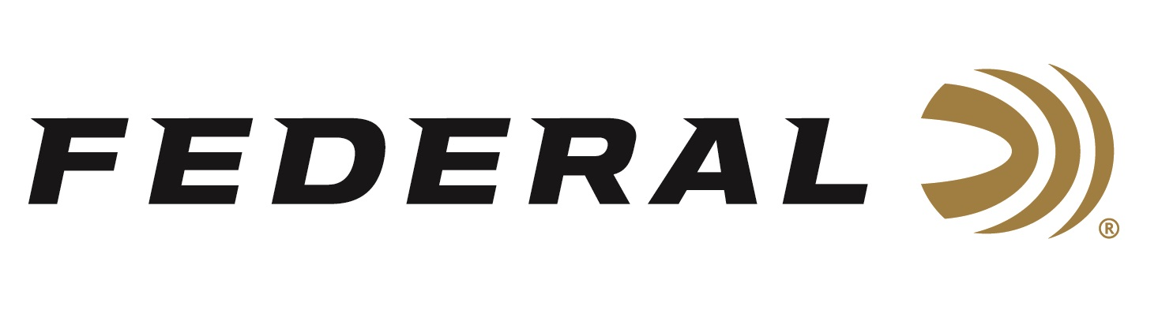

FOR IMMEDIATE RELEASE

**Federal’s New Power-Shok 10mm Auto for Handgun Hunting**

**Now Shipping**

**ANOKA, Minnesota – March 26, 2025 –** Federal Ammunition recently added a new 10mm Auto, 200-grain Jacketed Soft Point (JSP) load to its Handgun Hunting Power-Shok ammunition product line. The new product is ideal for those seeking an accurate and terminally effective bullet suitable for a variety of big game when hunting with a handgun. The new load is currently being delivered to retailers nationwide.

[Power-Shok Handgun, 10mm Auto, 200 Grain, Jacketed Hollow Point](https://www.federalpremium.com/handgun/power-shok-handgun/11-C10A.html)

“Handgun hunters seeking a short-barrel performance that goes the distance can always rely on Federal Power-Shok loads for the reliability and accuracy they need at an affordable price,” said Chris Laack, Federal Handgun Ammunition Product Manager. “This new Power-Shok load addresses the needs of any handgun hunter, offering a reliable hollow-point bullet for hunting with 10mm handguns, and is also offered at a price point to meet a specific budget.”

This new hunting handgun load features clean-burning powders, reliable Federal primers, reloadable brass cases, and quality, accurate jacketed hollow-point bullets suited to a variety of big game. It is sold in 20-count boxes.

**Part No. / Description / MSRP**

C10A / 10mm Auto, 200-grain, Jacketed Hollow Point, 1,110 fps / $37.99

Federal Ammunition products are available at dealers nationwide and online. For more information on all Federal products and to sign up to receive notifications about new product availability, rebate promotions, and other brand news via email, visit [www.federalpremium.com](http://www.federalpremium.com).

**Press Release Contact:** JJ Reich

Senior Manager – Press Relations

E-mail: media@tkghunt.com

**About Federal Ammunition**

Federal, headquartered in Anoka, MN, is an ammunition brand of The Kinetic Group, owned by CSG, a globally diversified industrial group based in Prague (Czech Republic). From humble beginnings nestled among the lakes and woods of Minnesota, Federal Ammunition has evolved into one of the world's largest producers of sporting ammunition. In 1922, founding President Charles L. Horn paved the way for our success. Today, Federal carries on Horn's vision for quality products and services with the next generation of outdoorsmen and women. We maintain our position as experts in the science of ammunition production. Every day, Federal manufactures products to enhance our customers' shooting experience while partnering with the conservation organizations that protect and support our outdoor heritage. Federal offers thousands of options in our Federal Premium® and standard Federal® lines, making it the most complete ammunition company in the business and helping it provide customers with a choice no matter what the pursuit.