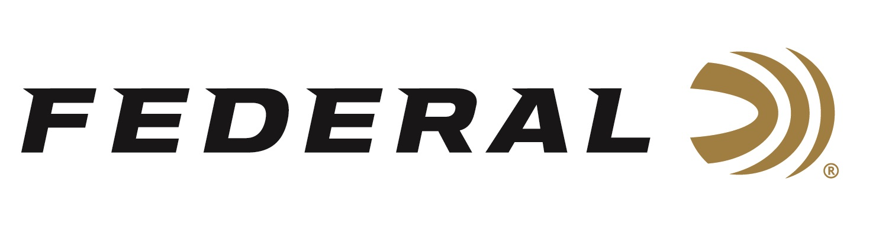

FOR IMMEDIATE RELEASE

**Federal’s New Rob Roberts Raptor Steel Now Shipping**

**ANOKA, Minnesota – July 15, 2025 –** Federal Ammunition has recently launched a new waterfowl hunting ammunition line in Rob Roberts Raptor Steel. Federal’s shotshell engineers collaborated with experts at the Rob Roberts Custom Gunworks to design these specialized waterfowl loads, which pair heavy payloads and high shot counts to put more pellets on target through Raptor Series chokes. The new product is currently being delivered to retailers nationwide.

[Rob Roberts Raptor Steel](https://www.federalpremium.com/shotshell/rob-roberts-raptor-steel/)

“Rob Roberts and his team helped us develop these customized loads, which pair heavy payloads and high pellet counts with carefully selected velocities proven to put more pellets on target,” said Federal’s Shotshell Product Director, Dan Compton. “The loads combine Federal’s high-performance primers and clean-burning propellant to deliver lethal shot strings through the advanced Raptor choke design.”

“These new loads are pure poison with looks that kill, and it flat-out crushes ducks and geese,” said Rob Roberts. “Federal’s standard, blue-box, Speed-Shok loads have always been a go-to for me. And with our help, this new load is that standard on steroids. The heavy 1 3/8-ounce set at an ideal speed of 1,400 fps that produces an unbelievable, consistent pattern priced right for its performance level. Precise, killer patterns are what make any hunter successful. This balanced load delivers on that.”

**Part No. / Description / MSRP**

RRS138 2 / Raptor Steel 12-ga, 3-inch, 1 3/8-ounce, 1,400 fps No 2 / $30.99

Federal Ammunition products are available at dealers nationwide and online. For more information on all Federal products and to sign up to receive notifications about new product availability, rebate promotions, and other brand news via email, visit [www.federalpremium.com](http://www.federalpremium.com).

**Press Release Contact:** JJ Reich  
Senior Manager – Press Relations  
E-mail: [media@tkghunt.com](mailto:media@tkghunt.com)

**About Federal Ammunition**

Federal, headquartered in Anoka, MN, is an ammunition brand of The Kinetic Group, owned by CSG, a globally diversified industrial group based in Prague, Czech Republic. Since 1922, Federal has been a leader in ammunition innovation, delivering high-quality sporting and hunting products to shooters worldwide. With a commitment to conservation and the outdoor community, Federal continues to manufacture industry-leading ammunition that enhances the shooting experience while supporting outdoor traditions.