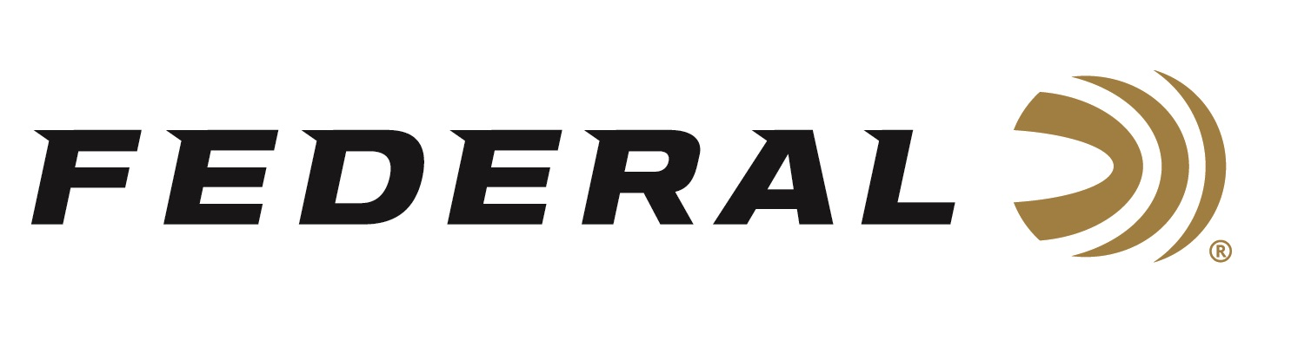

FOR IMMEDIATE RELEASE

**Sporting Arms and Ammunition Manufacturers' Institute Publishes**

**7mm Backcountry Cartridge Specifications**

**ANOKA, Minnesota** – **February 10, 2025** – The Sporting Arms and Ammunition Manufacturers’ Institute (SAAMI) recently announced the acceptance of Federal’s new 7mm Backcountry (7mm BC) rifle cartridges for SAAMI standardization. SAAMI is the organization leading the charge in promoting firearm safety by creating standards that ensure the safety, reliability, and interchangeability of firearms, ammunition, and components.

“We all at Federal are once again excited to have a new cartridge accepted by SAAMI,” said Federal’s Vice President of Product Development, Jesse Whiteside. “The 7mm Backcountry, with a 170-grain bullet traveling at a velocity of 3,000 fps and a Maximum Average Pressure of 80,000 psi, passed the organization's robust review process and is now an active standard. SAAMI’s published standards for the 7mm Backcountry will help expand this ultra-fast and accurate new cartridge to be used in shorter barreled, suppressed hunting rifles across the industry.”

Federal’s 7mm Backcountry is a new high-performance hunting cartridge boosted by new, patented Peak Alloy case technology. To learn more, visit <https://www.federalpremium.com/backcountry.html>.

SAAMI allows free access to technical data and drawings for the cartridge and chamber designs, which are posted in the Information and Specifications section of the organization’s website. All cartridge and chamber drawing documents are within the ANSI/SAAMI Standards and can be found on [www.saami.org](http://www.saami.org).

[New & Revised Cartridge & Chamber Drawings - SAAMI](https://saami.org/technical-information/cartridge-chamber-drawings/)

SAAMI was founded in 1926 at the federal government's request and tasked with creating and publishing industry standards for safety, interchangeability, reliability, and quality and coordinating technical data. SAAMI’s Technical Committee, which consists of firearm and ammunition industry experts, reviewed the 7mm Backcountry submission for about six months. The official cartridge name, maximum cartridge and minimum chamber dimensions, pressure limits, test equipment, and other characteristics are all considered and scrutinized during the process.

Federal Ammunition products are available at dealers nationwide and online. For more information on all Federal products, visit [www.federalpremium.com](http://www.federalpremium.com).

**Press Release Contact:** JJ Reich

Senior Manager – Press Relations

E-mail: media@tkghunt.com

**About Federal Ammunition**

Federal, headquartered in Anoka, MN, is an ammunition brand of The Kinetic Group, owned by CSG, a globally diversified industrial group based in Prague (Czech Republic). From humble beginnings nestled among the lakes and woods of Minnesota, Federal Ammunition has evolved into one of the world's largest producers of sporting ammunition. In 1922, founding President Charles L. Horn paved the way for our success. Today, Federal carries on Horn's vision for quality products and services with the next generation of outdoorsmen and women. We maintain our position as experts in the science of ammunition production. Every day, Federal manufactures products to enhance our customers' shooting experience while partnering with the conservation organizations that protect and support our outdoor heritage. Federal offers thousands of options in our Federal Premium® and standard Federal® lines, which is what makes it the most complete ammunition company in the business and helps it provide customers with a choice no matter what the pursuit.