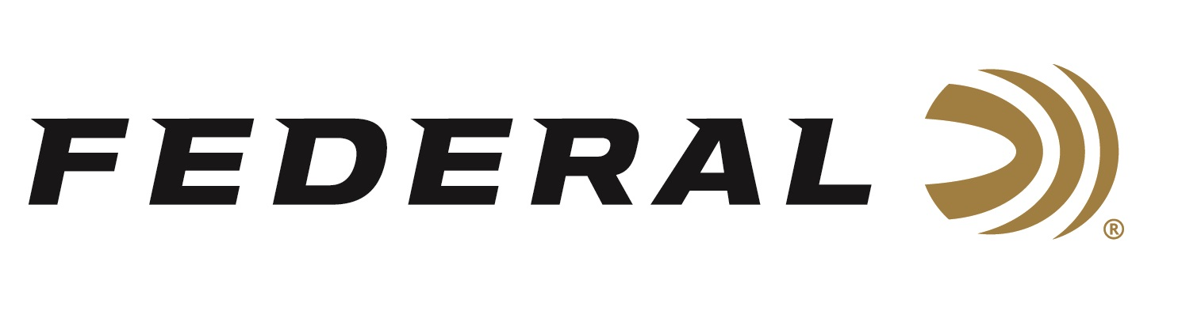

FOR IMMEDIATE RELEASE

**Federal Ammunition’s Derrick Mein Wins Three 2025 Jack Link's Cup Events**

**ANOKA, Minnesota –** **February 19, 2025 –** Federal Ammunition congratulates sponsored shooter Derrick Mein, a two-time Olympian, for his excellent performances at the 2025 Jack Link’s Cup. The Cup was held at Quail Creek Sporting Ranch in Okeechobee, Florida from February 10-16. It attracted more than 1,400 participants from across the world.

Team Federal’s Derrick Mein was the High Over All winner at three of the major events. These were the FITASC, the Thursday Prelim, and the North Prelim. He also earned the honor of Master Second in the Overall Jack Link’s Cup Main Event.

“The Jack Link’s Cup was a great experience, providing its own unique challenges as a shooter,” said Mein. “Changes in weather, along with challenging presentations, were at the top of that list. The confidence I have in the Federal Premium High Over All (HOA) shotshells I use for competition helped me overcome those challenges to beat some of the best competitors in the world.”

The Federal Premium High Over All product line now consists of 26 total options. Products come in a variety of payload weights, velocities, dram options, and shot sizes. Federal’s unique Podium wad design’s cylinder-shaped compression zone supports the payload and provides unmatched protection from deformation at ignition for the best patterns and fewer flyers. The soft-shooting wad’s unique profile allows it to be loaded in all tapered hulls. This is featured in all HOA’s 12- and 20-gauge options. Learn more at: [https://www.federalpremium.com/shotshell/high-over-all](https://www.federalpremium.com/shotshell/high-over-all/).

Federal Ammunition products are available at dealers nationwide and online. For more information on all Federal products, visit [www.federalpremium.com](http://www.federalpremium.com).

**Press Release Contact:** JJ Reich

Senior Manager – Press Relations

E-mail: media@tkghunt.com

**About Federal Ammunition**

Federal, headquartered in Anoka, MN, is an ammunition brand of The Kinetic Group, owned by CSG, a globally diversified industrial group based in Prague (Czech Republic). From humble beginnings nestled among the lakes and woods of Minnesota, Federal Ammunition has evolved into one of the world's largest producers of sporting ammunition. In 1922, founding President Charles L. Horn paved the way for our success. Today, Federal carries on Horn's vision for quality products and services with the next generation of outdoorsmen and women. We maintain our position as experts in the science of ammunition production. Every day, Federal manufactures products to enhance our customers' shooting experience while partnering with the conservation organizations that protect and support our outdoor heritage. Federal offers thousands of options in our Federal Premium® and standard Federal® lines, which is what makes it the most complete ammunition company in the business and helps it provide customers with a choice no matter what the pursuit.