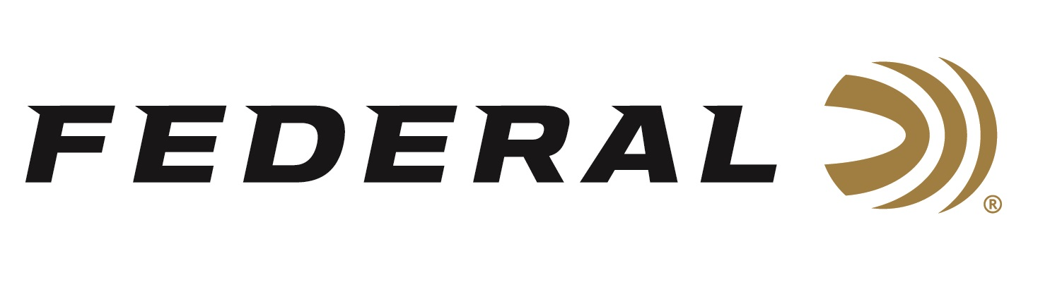

FOR IMMEDIATE RELEASE

**Federal Ammunition Sponsored Shooters Shine at the 2025 Shotgun Nationals, Derrick Mein Wins Trap Gold**

**ANOKA, Minnesota –** **June 3, 2025 –** The 2025 USA Shooting Skeet National Championship, May 21 - 25, and Trap National Championship, May 28 - June 1, recently wrapped up with standout performances from several sponsored Federal Ammunition shooters. The competition was held at John A. Halter Shooting Sports Center at Hillsdale College in Hillsdale, Michigan, where national, junior national, and world championship teams were also named.

In Trap, Team Federal’s Mein Derrick took home Gold in the Men’s Open Match. In Skeet, Vincent Hancock took home Silver in the Men’s Open Match. Amber English took Bronze in the Women’s Open Match.

“These athletes are true competitors and champions,” said Federal’s Vice President of Marketing Jason Nash. “We know that talents of this level must trust the best equipment available, and we are proud to have all of them as part of Team Federal. We congratulate their accomplishments at the 2025 Shotgun Nationals, and we look forward to seeing more successes at upcoming matches.”

The 2025 International Shooting Sports Federation (ISSF) World Championship Teams were also named at this event, which included sponsored athletes Vincent Hancock (4-time Olympic Gold Medalist) and Conner Prince (Paris 2024 Olympic Silver Medalist) in Men’s Skeet, and Derrick Mein (2-time Olympian) in Men’s Trap. Hancock and Prince were also named to the Open Team for Men’s Skeet, as well as Caitlin Connor in Women’s Skeet. Mein was named to the Open Team for Men’s Trap.

At the awards ceremony, Conner Prince, Paris 2024 Olympic silver medalist, was presented with the Civilian Marksmanship Program Distinguished International Shooters Badge. The badge is the highest award for international marksmanship excellence. Conner is among only three USA Shooting athletes who earned the award in 2024.

Federal is the number one choice for shotgun shells and manufactures product in America for all competitive and recreational disciplines. See the full lineup, including the brand's latest and greatest target loads: [High Over All](https://www.federalpremium.com/shotshell/high-over-all/) and [Master Class](https://www.federalpremium.com/shotshell/master-class/).

To support America’s shooting team, visit [www.usashooting.org](http://www.usashooting.org) to find out more.

Federal Ammunition products are available at dealers nationwide and online. For more information on all Federal products, visit [www.federalpremium.com](http://www.federalpremium.com).

**Press Release Contact:** JJ Reich

Senior Manager – Press Relations

E-mail: media@tkghunt.com

**About Federal Ammunition**

Federal, headquartered in Anoka, MN, is an ammunition brand of The Kinetic Group, owned by CSG, a globally diversified industrial group based in Prague (Czech Republic). From humble beginnings nestled among the lakes and woods of Minnesota, Federal Ammunition has evolved into one of the world's largest producers of sporting ammunition. In 1922, founding President Charles L. Horn paved the way for our success. Today, Federal carries on Horn's vision for quality products and services with the next generation of outdoorsmen and women. We maintain our position as experts in the science of ammunition production. Every day, Federal manufactures products to enhance our customers' shooting experience while partnering with the conservation organizations that protect and support our outdoor heritage. Federal offers thousands of options in our Federal Premium® and standard Federal® lines, which is what makes it the most complete ammunition company in the business and helps it provide customers with a choice no matter what the pursuit.