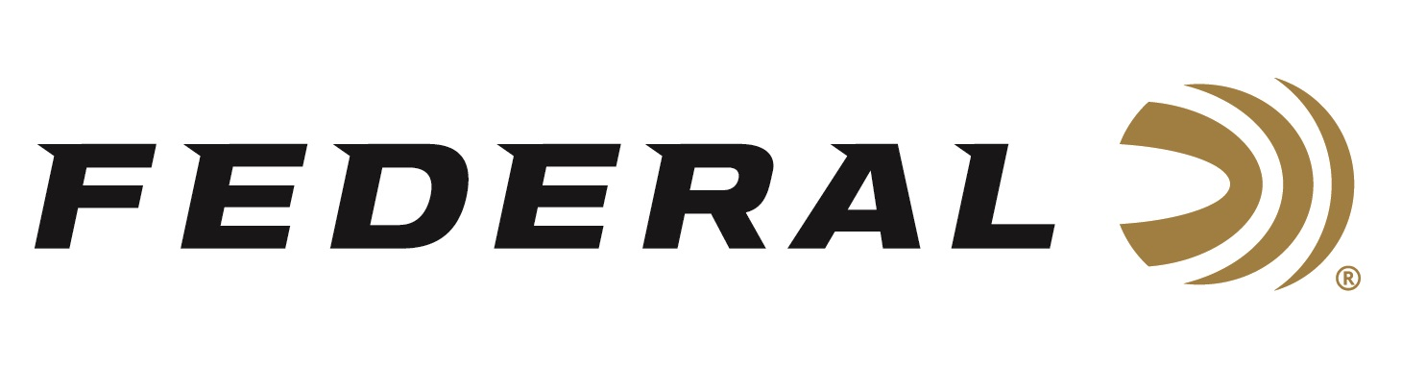

FOR IMMEDIATE RELEASE

**Five Federal Ammunition Sponsored Shooters Named to the 2025 U.S. National Shotgun Team**

**ANOKA, Minnesota –** **February XX, 2025 –** Federal Ammunition congratulates sponsored shooters for successful finishes at the recent 2025 Trap Spring Selection Matches. Derrick Mein, a two-time Olympian, and Brian Burrows, 2020 Tokyo bronze medalist, were named to the USA Shooting 2025 National Men’s Trap Team. Vincent Hancock, four-time Olympic champion, won the Men’s Skeet Spring Selection match, and Caitlin Connor placed third in the Women’s Selection Match. New to Team Federal, Ben Keller won the Junior Division for Skeet. These wins earned their places on the 2025 U.S. National Shotgun Team as well.

The qualification matches took place January 22-26 for Trap and January 29-February 2 for Skeet, at the Palm Beach County Shooting Sports Complex in West Palm Beach, Florida. More than a hundred athletes from across the country competed to make a team or earn a medal. Competitors shot 250 targets in the qualification round, aiming to shoot scores that would land them in the finals.

Federal manufactures products in America for all competitive and recreational disciplines and is a top choice for competition shotgun shells, which includes High Over All, Gold Medal Paper, and new-for-2025 Federal Master Class.

Engineered for the most elite trap, skeet, and sporting clay shooters, Federal Premium High Over All leaves a trail of shattered targets in its wake and more reloads per shell. It’s hard, high-antimony lead payload produces the most consistent patterns, while the solid brass head and hull design make reloading easier than ever. It's the ultimate competition load for the world's best shooters.

The look, feel and performance of Gold Medal Paper shotshells have made them the favorite of the most serious clay target shooters. Now they're even better, thanks to a high-quality brass head, harder shot, and modern wad options.

Master Class is a new competition-level sporting clay load features a customized Podium wad that extracts peak performance from Federal’s straight-wall hull. Reliable primers, high-antimony lead shot and select propellant combine to break the most challenging targets.

To support America’s shooting team, visit [www.usashooting.org](http://www.usashooting.org) to find out more.

Federal Ammunition products are available at dealers nationwide and online. For more information on all Federal products, visit [www.federalpremium.com](http://www.federalpremium.com).

**Press Release Contact:** JJ Reich

Senior Manager – Press Relations

E-mail: media@tkghunt.com

**About Federal Ammunition**

Federal, headquartered in Anoka, MN, is an ammunition brand of The Kinetic Group, owned by CSG, a globally diversified industrial group based in Prague (Czech Republic). From humble beginnings nestled among the lakes and woods of Minnesota, Federal Ammunition has evolved into one of the world's largest producers of sporting ammunition. In 1922, founding President Charles L. Horn paved the way for our success. Today, Federal carries on Horn's vision for quality products and services with the next generation of outdoorsmen and women. We maintain our position as experts in the science of ammunition production. Every day, Federal manufactures products to enhance our customers' shooting experience while partnering with the conservation organizations that protect and support our outdoor heritage. Federal offers thousands of options in our Federal Premium® and standard Federal® lines, which is what makes it the most complete ammunition company in the business and helps it provide customers with a choice no matter what the pursuit.