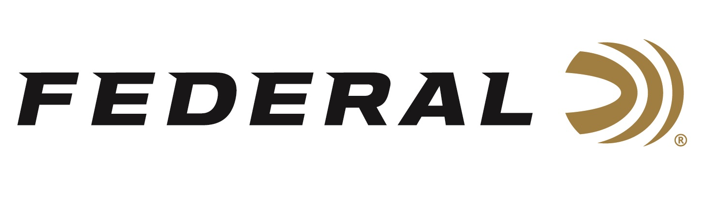

FOR IMMEDIATE RELEASE

**Federal Ammunition Awards 2025 Tom Knapp Memorial Scholarships**

**ANOKA, Minnesota – June 26, 2025 –** Federal Ammunition recently awarded the 2025 Tom Knapp Memorial Scholarships to two 4-H shooting sports teen ambassadors: Lucy Evans from Georgia and John Bruner from Pennsylvania. The scholarships were presented to the recipients at the National 4H Shooting Sports Invitational held in Grand Island, Nebraska, June 23-27. Jon Zinnel, Director of Community Relations for Federal Ammunition, announced the winners during the opening ceremonies.

In addition to the scholarships, Federal was there to celebrate the 4H Shooting Sports Program successes and welcome over 700 athletes from nearly 40 states. Federal remains the longest-tenured sponsor of the program, which introduces hundreds of thousands of new shooting sports enthusiasts to a wide array of shooting disciplines. Each year, the county programs offer safe and controlled shooting sports programs led by certified instructors. This year marked the 25th Anniversary of the annual championships.

“Both Lucy and John had an impressive resume of community service and giving back to their communities and the shooting sports community,” said Jon Zinnel. “I started in the shooting sports industry when I, too, served as a National 4-H Shooting Sports Ambassador. All the National Ambassadors are tremendous citizens, which is a testament to the great programs the organization offers to youth across the country.”

The Tom Knapp Memorial Scholarship program, an annual initiative, was established to honor the memory of the legendary exhibition shooter Tom Knapp. Before his passing in April 2013, Knapp left an indelible mark on the shooting sports community. In 2016, Federal Ammunition and Champion Traps & Targets, in collaboration with the National 4-H Shooting Sports Committee, took up the mantle to continue this esteemed scholarship program.

Knapp, a passionate advocate for nurturing the next generation, was a respected Champion and Federal Ammunition ambassador. With the support of Knapp’s wife, Colleen, Champion extended Tom’s licensed products program to fund an endowed scholarship that annually awards $2,500 to two National 4-H Ambassadors.

Federal Ammunition products are available at dealers nationwide and online. For more information on all Federal products and to sign up to receive notifications about new product availability, rebate promotions, and other brand news via email, visit [www.federalpremium.com](http://www.federalpremium.com).

**Press Release Contact:**  
JJ Reich  
Senior Manager – Press Relations  
E-mail: [media@tkghunt.com](mailto:media@tkghunt.com)

**About Federal Ammunition**

Federal, headquartered in Anoka, MN, is an ammunition brand of The Kinetic Group, owned by CSG, a globally diversified industrial group based in Prague, Czech Republic. Since 1922, Federal has been a leader in ammunition innovation, delivering high-quality sporting and hunting products to shooters worldwide. With a commitment to conservation and the outdoor community, Federal continues to manufacture industry-leading ammunition that enhances the shooting experience while supporting outdoor traditions.