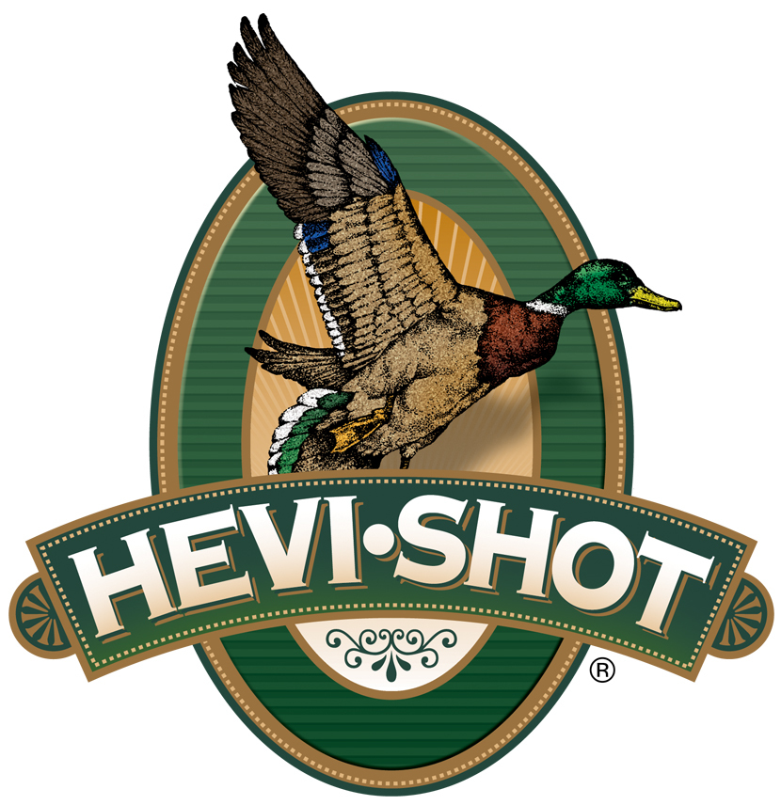

FOR IMMEDIATE RELEASE

New HEVI-Bismuth and HEVI-13 Turkey Loads Now Shipping

SWEET HOME, Oregon – February 21, 2025 – HEVI-Shot Ammunition recently launched several new turkey loads for the upcoming 2025 spring season, and retailers are now stocking shelves with them. Two new HEVI-Bismuth Turkey 3-inch, 12- and 20-gauge offerings in 4/5 shot, and four HEVI-13 3-inch, 12- and 20-gauge offerings in 6 or 7 shot are currently being delivered to retailers nationwide.

“We are excited to be shipping our new-for-2025 loads to turkey hunters gearing up for a great spring season,” said Tina Larsen, HEVI-Shot’s marketing manager. “This includes an entirely new product line in HEVI-Bismuth Turkey. Plus, HEVI-Shot’s original HEVI-13 product line is returning. These products offer excellent, hard-hitting solutions for hunters seeking non-leaded options at specific price points.”

The new HEVI-Bismuth Turkey product line comprises two 3-inch 12- and 20-gauge offerings. With a blend of 4 and 5 shot made with 9.6 g/cc HEVI-Bismuth, turkey hunters get blistering speed and 22 percent more energy compared to steel. Learn more at:
https://www.hevishot.com/turkey/hevi-bismuth-turkey.

HEVI-Shot’s original HEVI-13 returns in 2025. It comprises four 3-inch 12- and 20-gauge offerings in 6 and 7 shot. Loaded with HEVI-Shot 12 g/cc tungsten, HEVI-13 offers 20 percent more effective range and energy than lead turkey payloads. Learn more at: https://www.hevishot.com/turkey/hevi-13-turkey.

Part No. / Description / MSRP
HSBT412045 / HEVI-Bismuth Turkey 12g, 3”, 4 & 5, 1¾ oz, 5-count box / $23.99
HSBT420045 / HEVI-Bismuth Turkey 20g, 3”, 4 & 5, 1¼ oz, 5-count box / $20.99
HS43026 / HEVI-13 12g, 3”, 6, 2 oz, Tungsten, 5-count box / $50.99
HS43027 / HEVI-13 12g, 3”, 7, 2 oz, Tungsten, 5-count box / $50.99
HS306 / HEVI-13 20g, 3”, 6, 1¼ oz, 5-count box / $39.99
HS307 / HEVI-13 20g, 3”, 7, 1¼ oz, 5-count box / $39.99

HEVI-Shot products are available at dealers nationwide and online. For more information on all HEVI-Shot products, visit www.hevishot.com.

Press Release Contact: JJ Reich
Senior Manager – Press Relations
E-mail: media@tkghunt.com

About HEVI-Shot
Established in 2000 and based out of Sweet Home, Oregon, HEVI-Shot is a brand of The Kinetic Group, owned by CSG, a globally diversified industrial group based in Prague (Czech Republic). HEVI-Shot is an industry leader in performance shotshell, providing the next generation of shotshell loads to hunters—with their large and impressive selection of hunting ammunition options. HEVI-Shot is synonymous with high performance projectiles. The company meticulously designs each product to outperform any ammunition competitor in its class. That is why HEVI-Shot is the ammunition choice for serious hunters who live by their slogan: “I DIDN’T COME THIS FAR TO MISS!”

