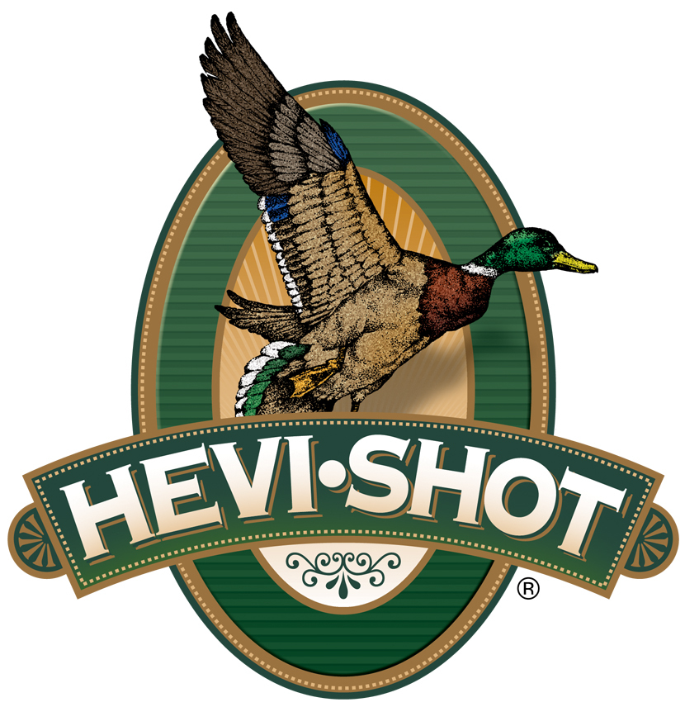

FOR IMMEDIATE RELEASE

HEVI-Shot Will Release 35 New Shotshell Options in 2025

SWEET HOME, Oregon – January 14, 2025 – HEVI-Shot is proud to announce 35 new shotgun loads to be released in 2025, including two entirely new product lines: HEVI-Hitter and HEVI-Bismuth Turkey. New load offerings will also be added to the existing HEVI-Hammer, HEVI-Metal Longer Range, HEVI-Steel, HEVI-XII, Magnum Blend, HEVI-18, and more.

The new HEVI-Hitter product line comprises 11 offerings in 12, 16, 20 and 28 gauge.
It devotes 20 percent of its payload to 12 g/cc tungsten and layers it over 80 percent steel shot, balancing the sheer power of tungsten with the patterning and practicality of steel to deliver better lethality on ducks and geese. Due to both types of pellets being the same shot size, the tungsten layer hits 54-percent harder in terms of kinetic energy and momentum delivering exceptional impact performance.

The new HEVI-Bismuth Turkey product line comprises two 3-inch 12- and 20-gauge offerings. With a blend of 4 and 5 shot made with 9.6 g/cc HEVI-Bismuth, turkey hunters get blistering speed and 22 percent more energy compared to steel.

Fourteen new product line additions for waterfowl hunters include a new loading of HEVI-Hammer in 12-gauge, 3-inch, BB, four new HEVI-Metal Longer Range 16-gauge offerings in BB, 2, 4 and 6 shot, eight new HEVI-Steel additions in 12, 16 and 20 gauge, in both layered and standard payloads, and one new HEVI-XII 2 3/4-inch 20-gauge line extension in 3 shot.

The HEVI-Steel Upland will receive four new 12- and 20-gauge product line extensions in 2 3/4-inch with 3, 5, 6, and 7 shot. These new loads are ideal for larger upland birds like pheasants. HEVI-Steel Upland is pushed faster than competing steel loads, making it easier to connect on hard-flying birds and delivering more energy on impact.

Several additional new loadings will be available for turkey hunters, including two Magnum Blend 28-gauge offerings in 2 3/4- and 3-inch, 5, 6, 7 shot. Plus, there are two 28-gauge 2 3/4-inch new options in 7 and 9 shot. In addition, HEVI-Shot’s HEVI-13 product line will be returning. It comprises of four 3-inch 12- and 20-gauge offerings in 6 and 7 shot. Loaded with HEVI-Shot 12 g/cc tungsten, HEVI-13 offers 20 percent more effective range and energy than lead turkey payloads.

These all-new products will be showcased and on display at the 2025 SHOT Show, January 21–24 at the Venetian Expo and Caesars Forum in Las Vegas, Nevada. Attendees of the show are encouraged to stop by Booth No. 11838 for a first-hand look at these new products and more.

Information about the new products for 2025 can be found on HEVI-Shot’s brand website soon after the SHOT Show. Sign up to receive exclusive access to online promotions and news via email by visiting HEVI-Shot - Sign Up.

HEVI-Shot products are available at dealers nationwide and online. For more information on all HEVI-Shot products, visit www.hevishot.com.

Press Release Contact: JJ Reich
Senior Manager – Press Relations
E-mail: media@tkghunt.com

About HEVI-Shot
Established in 2000 and based out of Sweet Home, Oregon, HEVI-Shot is a brand of The Kinetic Group, owned by CSG, a globally diversified industrial group based in Prague (Czech Republic). HEVI-Shot is an industry leader in performance shotshell, providing the next generation of shotshell loads to hunters—with their large and impressive selection of hunting ammunition options. HEVI-Shot is synonymous with high performance projectiles. The company meticulously designs each product to outperform any ammunition competitor in its class. That is why HEVI-Shot is the ammunition choice for serious hunters who live by their slogan: “I DIDN’T COME THIS FAR TO MISS!”

