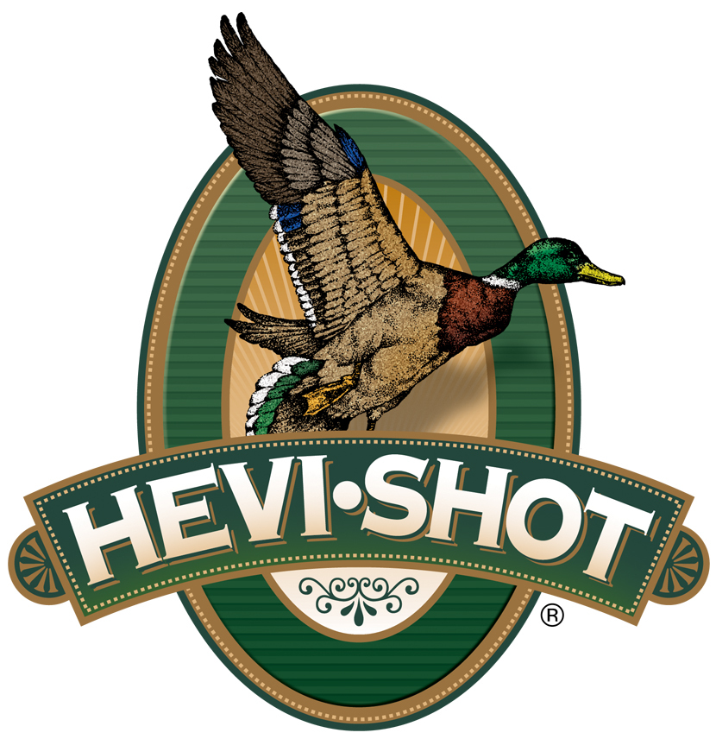

FOR IMMEDIATE RELEASE

Experience HEVI-Shot at Reeds Gun Fair May 2-4, 2025

SWEET HOME, Oregon – April 24, 2025 – HEVI-Shot will attend the upcoming try-before-you-buy event at Reed's Gun Fair, May 2-4, 2025. The event will be held near Little Falls, Minnesota, at the scenic Rice Creek Hunting & Recreation Area.

Event Highlights Include Hands-on firearm testing with live ranges, exclusive show deals on firearms and accessories, opportunities to meet and learn from manufacturer experts, free instructional courses for trap shooting, concealed carry, and much more, such as food vendors, shooting shows, outdoor gear displays, and other family-friendly activities.
Whether you’re a seasoned hunter or new to shooting sports, Reeds Gun Fair is the ultimate event to test and compare ammunition from top brands, including the HEVI-Shot Hevi-Bismuth 12-gauge, 2-3/4-inch, 1-1/4-ounce, No. 2 shot, Hevi-Hammer 12-gauge, 3-inch, 1-1/4-ounce, No. 2, and Hevi-Steel 12-gauge, 3-inch, 1-1/4-ounce, No. 2. Attendees can experience free live shooting on a variety of ranges designed for different firearm types, all while enjoying expert guidance from manufacturer representatives.

“We’re thrilled to showcase our HEVI-Shot lineup at the Reeds Gun Fair,” said Adam Arnold of Reeds. “This event is a must-attend for anyone interested in testing high-quality firearms in a real-world environment before making a purchase.”
In addition to the exciting lineup of gear, the local chapter of Ducks Unlimited will be on-site, providing attendees with a great way to support wildlife conservation efforts while enjoying the event sponsored by Ducks Unlimited. A portion of proceeds from select activities will go toward Ducks Unlimited’s mission to preserve and restore habitats for waterfowl and other wildlife.

Visit the official event page at www.reedsgunfair.com for more details and updates on participating manufacturers.

HEVI-Shot products are available at dealers nationwide and online. For more information on all HEVI-Shot products, visit www.hevishot.com.

Press Release Contact: JJ Reich
Senior Manager – Press Relations
E-mail: media@tkghunt.com

About HEVI-Shot
Established in 2000 and based out of Sweet Home, Oregon, HEVI-Shot is a brand of The Kinetic Group, owned by CSG, a globally diversified industrial group based in Prague (Czech Republic). HEVI-Shot is an industry leader in performance shotshell, providing the next generation of shotshell loads to hunters—with their large and impressive selection of hunting ammunition options. HEVI-Shot is synonymous with high performance projectiles. The company meticulously designs each product to outperform any ammunition competitor in its class. That is why HEVI-Shot is the ammunition choice for serious hunters who live by their slogan: “I DIDN’T COME THIS FAR TO MISS!”

