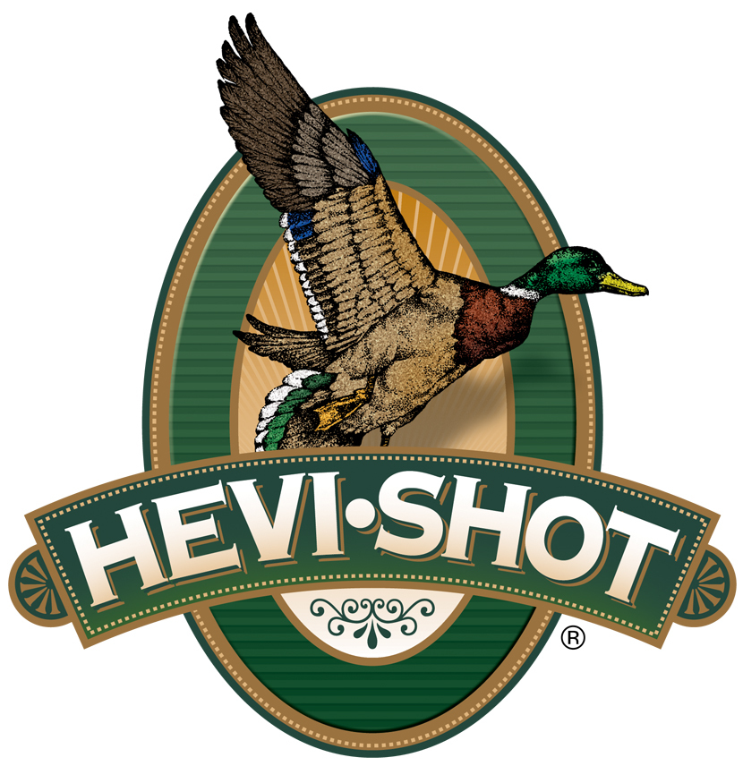

FOR IMMEDIATE RELEASE

HEVI-Shot Ammunition’s Steel Deals Rebate Program Is Under Way

SWEET HOME, Oregon – February 11, 2025 – HEVI-Shot recently announced its Steel Deals Rebate Program, where diehard hunters can get up to $200 back on HEVI-Steel or HEVI-Steel Upland shotshell ammunition.

To take advantage of the Steel Deals Rebate, shooters need to buy at least two (2) boxes of HEVI-Shot HEVI-Steel or HEVI-Steel Upland shotshell ammunition to get a $5.00 per box rebate. A minimum purchase of two (2) boxes or one (1) 100-count bulk pack is required. The maximum rebate is $200 per person or household. Valid purchases must be made January 9 through March 10, 2025. The deadline for online submission is March 31, 2025.

More information on HEVI-Shot’s Steel Deals rebate can be found at
https://www.hevishot.com/hevi-nation/rebates-and-promotions.html.

“Our Steel Deals rebate gives hunters a great opportunity to try our all-steel waterfowl and upland loads,” said HEVI-Shot’s Marketing Manager Tina Larsen. “For those who love our bismuth/steel and tungsten/steel loads but want an all-steel option to meet a specific price point for high-volume hunts such as snow goose and dove, HEVI-Steel and HEVI-Steel Upland are excellent choices.”

HEVI-Steel and HEVI-Steel Upland pushes payloads faster than competing steel loads. Their velocity boost makes it easier to connect on hard-flying birds and delivers more energy on impact. Aided by HEVI-Shot’s best-in-class wad and precision manufacturing techniques, these all-steel shotshells hit hard every time.

HEVI-Shot products are available at dealers nationwide and online. For more information on all HEVI-Shot products, visit www.hevishot.com.

Press Release Contact: JJ Reich
Senior Manager – Press Relations
E-mail: media@tkghunt.com

About HEVI-Shot
Established in 2000 and based out of Sweet Home, Oregon, HEVI-Shot is a brand of The Kinetic Group, owned by CSG, a globally diversified industrial group based in Prague (Czech Republic). HEVI-Shot is an industry leader in performance shotshell, providing the next generation of shotshell loads to hunters—with their large and impressive selection of hunting ammunition options. HEVI-Shot is synonymous with high performance projectiles. The company meticulously designs each product to outperform any ammunition competitor in its class. That is why HEVI-Shot is the ammunition choice for serious hunters who live by their slogan: “I DIDN’T COME THIS FAR TO MISS!”

HEVI-Shot R10375 – Steel Deals

