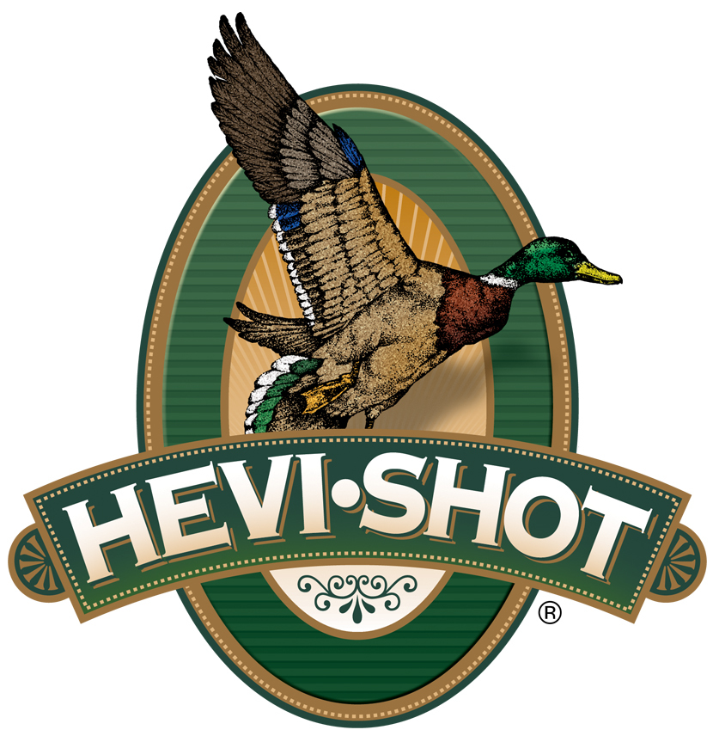

FOR IMMEDIATE RELEASE

HEVI-Shot Ammunition Kicks Off Its Tom Time Rebate Program

SWEET HOME, Oregon – March 6, 2025 – HEVI-Shot recently announced its Tom Time rebate program, where diehard wild turkey hunters can get up to $100 back after buying some HEVI-Shot turkey loads. This promotion runs through May 31, 2025.

To take advantage of this rebate, customers must purchase HEVI-Shot’s HEVI-13, HEVI-Metal Turkey, Magnum Blend, Magnum Blend Reduced Recoil, HEVI-X Strut or HEVI-Bismuth Turkey to receive a $5.00 rebate per box or HEVI-Shot HEVI-18 to receive $7 per box back.

A minimum purchase of two (2) boxes is required, with a maximum rebate of $100.00 per person or household. Valid purchases must be made from March 1 through May 31, 2025. The deadline for submission of this rebate offer is June 30, 2025.

Loaded with HEVI-Shot 12 g/cc tungsten, HEVI-13 offers 20 percent more effective range and energy than lead turkey payloads. The high-density material also yields higher pellet counts for better pattern density and an excellent number of lethal hits on target.

HEVI-18 TSS Turkey uses high-density 18 g/cc pellets and our friction-reducing spherical buffer to extend effective range beyond what's ever been possible. Pushed at high velocities, TSS pellets carry more energy farther downrange, allowing hunters to drop three shot sizes from their go-to lead payloads and get higher pellet counts and denser patterns.

With a blend of 4 and 5 shot made with 9.6 g/cc HEVI-Bismuth, you get blistering speed and 22 percent more energy compared to steel. Our HEVI-Shot wad puts more of those pellets on gobblers, and the reliable primer and propellant deliver in any weather.

HEVI-Shot® Magnum Blend combines No. 5, 6 and 7 shot cast from 12 g/cc tungsten. The heavy, high-density payloads offer as many as 448 pellets in a single 12-gauge 3-inch shell, and those pellets carry far more energy than lead, extending the effective range and improving pattern density.

More information on HEVI-Shot’s Steel Deals rebate can be found at
https://www.hevishot.com/hevi-nation/rebates-and-promotions.html.

HEVI-Shot products are available at dealers nationwide and online. For more information on all HEVI-Shot products, visit www.hevishot.com.

Press Release Contact: JJ Reich
Senior Manager – Press Relations
E-mail: media@tkghunt.com

About HEVI-Shot
Established in 2000 and based out of Sweet Home, Oregon, HEVI-Shot is a brand of The Kinetic Group, owned by CSG, a globally diversified industrial group based in Prague (Czech Republic). HEVI-Shot is an industry leader in performance shotshell, providing the next generation of shotshell loads to hunters—with their large and impressive selection of hunting ammunition options. HEVI-Shot is synonymous with high performance projectiles. The company meticulously designs each product to outperform any ammunition competitor in its class. That is why HEVI-Shot is the ammunition choice for serious hunters who live by their slogan: “I DIDN’T COME THIS FAR TO MISS!”

