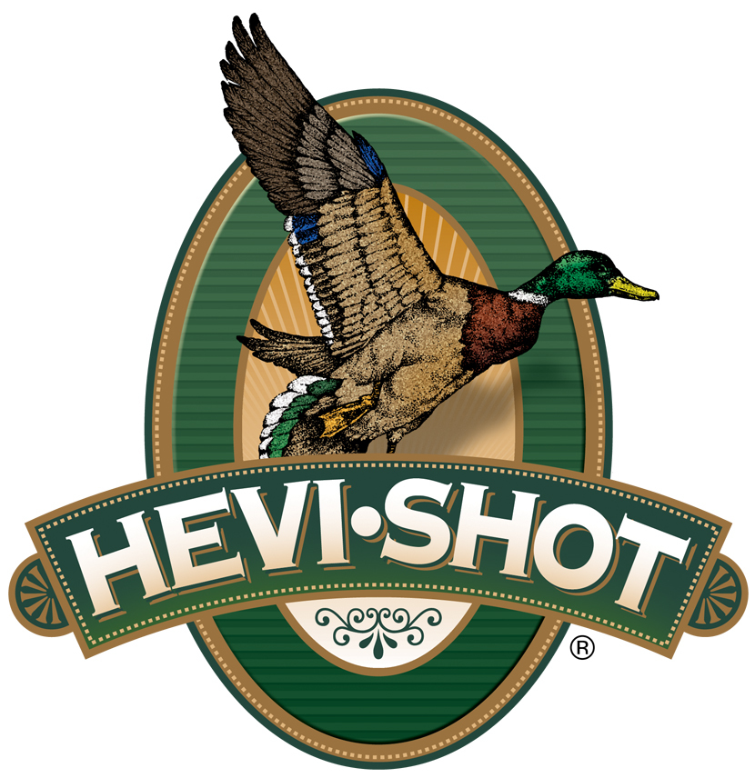

FOR IMMEDIATE RELEASE

HEVI-Shot Will Showcase New Turkey Loads and Host Brand Influencers at the 2025 NWTF Sport Show

SWEET HOME, Oregon – February 10, 2025 – HEVI-Shot will showcase new turkey loads and host several brand influencers in its booth at the National Wild Turkey Federation’s (NWTF) 49th Annual Convention and Sport Show. The premier event for turkey enthusiasts kicks off Wednesday, February 12, and runs through the 16th in Nashville, Tennessee.

“We are excited to showcase several additional new offerings available for turkey hunters,” said Tina Larsen, HEVI-Shot’s Marketing Manager. “This includes an entirely new product line in HEVI-Bismuth Turkey, new 28-gauge options in Magnum Blend and HEVI-18, and HEVI-Shot’s original HEVI-13 product line is returning! In addition, we will also be hosting some special guests in our booth this year. These brand influencers are excited to visit with fellow turkey hunters. It will be a great time."

The new HEVI-Bismuth Turkey product line comprises two 3-inch 12- and 20-gauge offerings. With a blend of 4 and 5 shot made with 9.6 g/cc HEVI-Bismuth, turkey hunters get blistering speed and 22 percent more energy compared to steel.

In HEVI-18 TSS, two 28-gauge 2 3/4-inch new options in 7 and 9 shot will join the two existing 28-gauge offerings in 3-inch. In Magnum Blend, a new 28-gauge 2 3/4-inch option in 5, 6, and 7 shot will join the existing 28-gauge option in 3-inch. This delivers six total options now available to turkey hunters in 28-gauge.

HEVI-Shot’s original HEVI-13 returns in 2025. It comprises four 3-inch 12- and 20-gauge offerings in 6 and 7 shot. Loaded with HEVI-Shot 12 g/cc tungsten, HEVI-13 offers 20 percent more effective range and energy than lead turkey payloads.

Attendees of the NWTF’s 2024 Convention and Sport Show are encouraged to stop by HEVI-Shot’s booth No. 1009 to talk with HEVI-Shot’s enthusiastic staff and brand influencers. On Thursday, Beau Brooks will appear from 1 to 2 p.m. and Jake Terry from 2 to 3 p.m. On Friday, Tony Vandemore will appear from 10 a.m. to 11 a.m., Shane Profit from 11 a.m. to 12 p.m., Justin Martin from 1 p.m. to 2 p.m., and Chad Hodge from 3 p.m. to 4 p.m. On Saturday, Jordan Summit will appear 10 a.m. to 11 a.m., Justin Martin from 1 p.m. to 2 p.m., and Maggie Williams from 3:30 to 5:30 p.m.

HEVI-Shot products are available at dealers nationwide and online. For more information on all HEVI-Shot products, visit www.hevishot.com.

Press Release Contact: JJ Reich
Senior Manager – Press Relations
E-mail: media@tkghunt.com

About HEVI-Shot
Established in 2000 and based out of Sweet Home, Oregon, HEVI-Shot is a brand of The Kinetic Group, owned by CSG, a globally diversified industrial group based in Prague (Czech Republic). HEVI-Shot is an industry leader in performance shotshell, providing the next generation of shotshell loads to hunters—with their large and impressive selection of hunting ammunition options. HEVI-Shot is synonymous with high performance projectiles. The company meticulously designs each product to outperform any ammunition competitor in its class. That is why HEVI-Shot is the ammunition choice for serious hunters who live by their slogan: “I DIDN’T COME THIS FAR TO MISS!”

