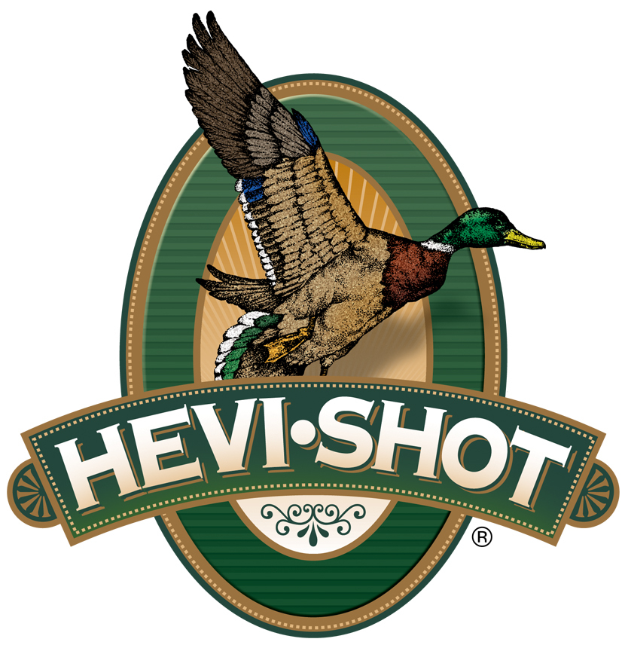

FOR IMMEDIATE RELEASE

New HEVI-Shot HEVI-XII 20-Gauge No. 2 Shotshells Now Shipping

SWEET HOME, Oregon – February 27, 2025 – HEVI-Shot expands its HEVI-XII tungsten load lineup by adding their new 20-gauge, 3-inch, 1,350-fps, No. 2 waterfowl load. This new load is now available and is shipping to dealers.

HEVI-XII

“For those looking to target waterfowl, such as snow goose in the spring, with sub-gauge shotguns, loads featuring HEVI-Shot’s original 12 g/cc tungsten pellets are always the most powerful option,” said Scott Turner, HEVI-Shot’s Shotshell Product Manager. “The new load is set to a 1,350-fps velocity with No. 2 shot, and it helps complete the list of popular waterfowl options in the HEVI-XII product family, bringing the total count of options up to nineteen!”

Loaded with HEVI-Shot’s original 12 g/cc tungsten, which is 53.8 percent denser than steel, these loads double the downrange energy, hitting birds harder from a longer distance. This means hunters can drop three shot sizes for the same lethality and still put 28 percent more pellets on target.

Technical Specifications:
Gauge: 20 Gauge
Shot Size: No. 2
Shotshell Length: 3-inch / 76mm
Muzzle Velocity: 1,350
Shot Charge Oz: 1 1/4
Type: Tungsten
Density: 12.0 g/cc
Package Quantity: 25
Usage: Waterfowl

Part No. / Description / MSRP
HS53202 / HEVI-XII 20 gauge, 3 inch, 1¼ ounce, No. 2 / $91.99

HEVI-Shot products are available at dealers nationwide and online. For more information on all HEVI-Shot products, visit www.hevishot.com.

Press Release Contact: JJ Reich
Senior Manager – Press Relations
E-mail: media@tkghunt.com

About HEVI-Shot
Established in 2000 and based out of Sweet Home, Oregon, HEVI-Shot is a brand of The Kinetic Group, owned by CSG, a globally diversified industrial group based in Prague (Czech Republic). HEVI-Shot is an industry leader in performance shotshell, providing the next generation of shotshell loads to hunters—with their large and impressive selection of hunting ammunition options. HEVI-Shot is synonymous with high performance projectiles. The company meticulously designs each product to outperform any ammunition competitor in its class. That is why HEVI-Shot is the ammunition choice for serious hunters who live by their slogan: “I DIDN’T COME THIS FAR TO MISS!”

