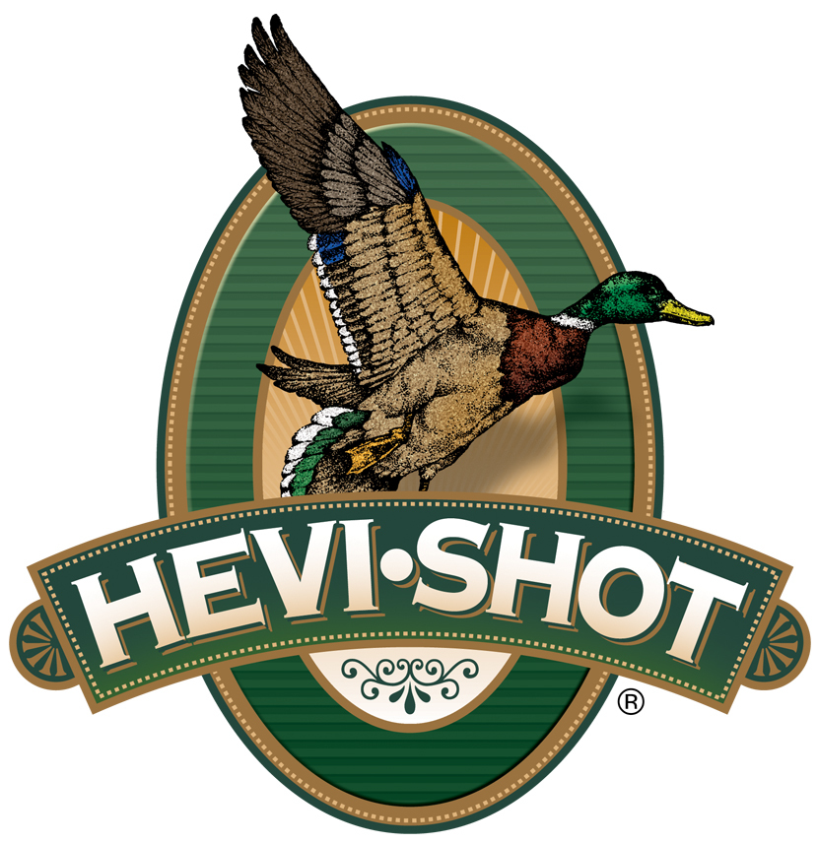

FOR IMMEDIATE RELEASE

HEVI-Shot’s 28-Gauge Magnum Blend and HEVI-18 Turkey Loads Now Shipping

SWEET HOME, Oregon – March 13, 2025 – HEVI-Shot recently expanded its 28-gauge Magnum Blend and HEVI-18 TSS turkey load options. Hevi-Shot’s two Magnum Blend 28-gauge options are 2 3/4- and 3-inch in No. 5, 6, 7 (combined) tungsten shot. Their four HEVI-18 TSS 28-gauge options are 2 3/4- and 3-inch in both No. 7 and 9 TSS shot. These shotshells are currently being delivered to retailers nationwide.

“Following in the footsteps of the 410 Bore, 28-gauge turkey shotguns are now soaring in popularity,” said Scott Turner, HEVI-Shot’s Shotshell Product Manager. “In response to that trend, we released 3-inch, 28-gauge options in our popular HEVI-18 TSS and Magnum Blend tungsten turkey load lineups last year with great success. This year, we are adding 2 3/4-inch options. Hunting with tungsten shot enables lighter-load sub-gauges to be ultra-effective in the turkey woods and shooting them is a lot of fun too.”

HEVI-Shot’s Magnum Blend combines No. 5, 6 and 7 shot, cast from 12 g/cc tungsten into one load. The heavy, high-density payloads offer as many as 448 pellets in a single 12-gauge 3-inch shell. The 12 g/cc tungsten shot carries far more energy than lead, extending the effective range and improving pattern density.

Magnum Blend

HEVI-Shot’s HEVI-18 TSS uses high-density 18 g/cc pellets and friction-reducing spherical buffer to extend effective range beyond what's ever been possible. Pushed at high velocities, TSS pellets carry more energy farther downrange, allowing hunters to drop three shot sizes from their go-to lead payloads and get higher pellet counts and denser patterns.

HEVI-18 TSS

Part No. / Description / MSRP
HS28567 / Magnum Blend, 28-gauge, 3-inch, No. 5/6/7, 1 ounce / $39.99
HS28340 / Magnum Blend, 28-gauge, 2 3/4-inch, No. 5/6/7, 15/16 ounce / $39.99
HS7287 / HEVI-18 TSS, 28-gauge, 3-inch, No. 7, 1 1/4 ounce / $61.99
HS7289 / HEVI-18 TSS, 28-gauge, 3-inch, No. 9, 1 1/4 ounce / $61.99
HS7287 / HEVI-18 TSS, 28-gauge, 3-inch, No. 7, 1 1/4 ounce / $61.99
HS7259 / HEVI-18 TSS, 28-gauge, 2¾-inch, No. 9, 11/16 ounce / $61.99

*All products are sold in 5-count boxes.

HEVI-Shot products are available at dealers nationwide and online. For more information on all HEVI-Shot products, visit www.hevishot.com.

Press Release Contact: JJ Reich
Senior Manager – Press Relations
E-mail: media@tkghunt.com

About HEVI-Shot
Established in 2000 and based out of Sweet Home, Oregon, HEVI-Shot is a brand of The Kinetic Group, owned by CSG, a globally diversified industrial group based in Prague (Czech Republic). HEVI-Shot is an industry leader in performance shotshell, providing the next generation of shotshell loads to hunters—with their large and impressive selection of hunting ammunition options. HEVI-Shot is synonymous with high performance projectiles. The company meticulously designs each product to outperform any ammunition competitor in its class. That is why HEVI-Shot is the ammunition choice for serious hunters who live by their slogan: “I DIDN’T COME THIS FAR TO MISS!”

