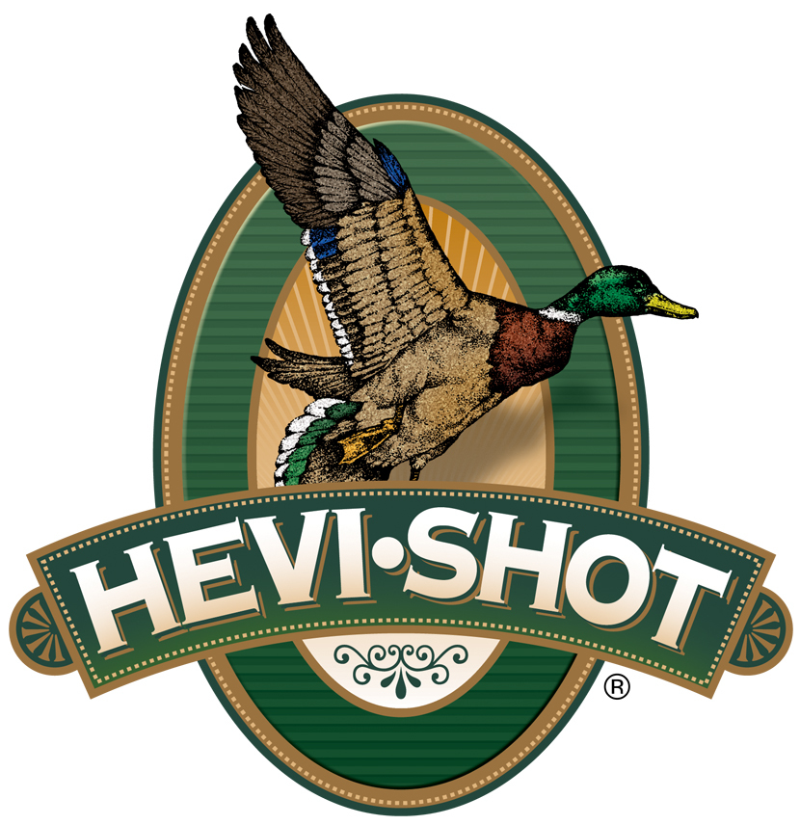

FOR IMMEDIATE RELEASE
HEVI-Shot Offers Fall Rebates on Waterfowl and Upland Loads
SWEET HOME, Oregon — August 4, 2025 — HEVI-Shot is giving hunters multiple ways to save this fall with three new rebate offers on its high-performance shotshell lines. Running from August 1 to December 31, 2025, these limited-time programs offer rebates on eligible purchases of waterfowl and upland ammunition.
“We’re proud to offer hunters a chance to save big on some of our most effective shotshells for the season,” said Bart Biedinger, Senior Manager of Trade Marketing. “Whether you're after performance on tough waterfowl, upland birds, or just want to stock up with serious value, HEVI-Shot’s lineup delivers consistent results and reliable performance in the field.”
Shoot HEVI-Shot & Save – Purchase at least two boxes of select HEVI-Shot waterfowl or upland ammunition and receive a rebate of $2 or $5 per box. Qualifying products include HEVI-Steel Waterfowl and HEVI-Steel Upland for $2 per box, and HEVI-Metal Xtreme, HEVI-Metal Longer Range, HEVI-Hitter for $5 per box.
Bismuth Bargains – Purchase at least two boxes of select HEVI-Shot HEVI-Bismuth ammunition and receive a rebate of $5 per box. Qualifying products include HEVI-Bismuth Waterfowl and HEVI-Bismuth Upland.
Hammering Deals – Purchase at least two boxes of select HEVI-Shot HEVI-Hammer ammunition and receive a rebate of $2 per box. Qualifying products include HEVI-Hammer, HEVI-Hammer Upland, and HEVI-Hammer Dove.
Valid purchase dates are August 1 through December 31, 2025. Rebate submissions must be received by January 31, 2026. Only select products are eligible—see official terms and conditions to learn more. Complete details on all of HEVI-Shot’s rebates can be found at: https://www.hevishot.com/hevi-nation/rebates-and-promotions.html.
HEVI-Shot products are available at dealers nationwide and online. For more information on all HEVI-Shot products and to sign up for product news, alerts, and promotions, visit www.hevishot.com.
Press Release Contact: JJ Reich
Senior Manager – Press Relations
E-mail: media@tkghunt.com

About HEVI-Shot
Established in 2000 and based out of Sweet Home, Oregon, HEVI-Shot is a brand of The Kinetic Group, owned by CSG, a globally diversified industrial group based in Prague (Czech Republic). HEVI-Shot is an industry leader in performance shotshell, providing the next generation of shotshell loads to hunters—with their large and impressive selection of hunting ammunition options. HEVI-Shot is synonymous with high performance projectiles. The company meticulously designs each product to outperform any ammunition competitor in its class. That is why HEVI-Shot is the ammunition choice for serious hunters who live by their slogan: “I DIDN’T COME THIS FAR TO MISS!”

