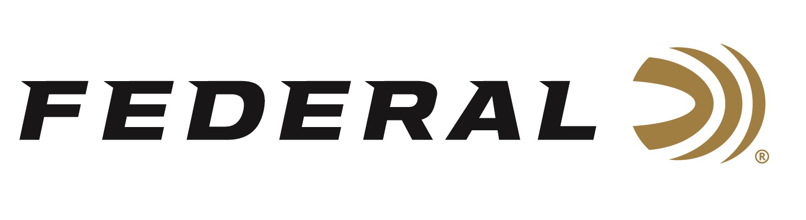
FOR IMMEDIATE RELEASE

Federal Ammunition Sponsored Shooter Varick Beise Wins Big in Texas

ANOKA, Minnesota – April 16, 2026 – Team Federal congratulates Varick Beise on winning the Open Division Championship at the 2026 MagPul Texas 3-Gun Championships, held April 10-12, at Reveille Peak Ranch near Burnet, Texas. This championship featured 10 stages set in the natural terrain of central Texas hill country, with round counts of 150-200 per platform, where the weather added extra challenges with frequently changing wind directions and a rainy, muddy final day.

“Running these stages will have you keeping an eye on your footing while trying to cover ground quickly in order to put down your best times,” reported Beise. “This match focused heavily on accuracy with all firearms, but still had a good balance with plenty of close-range shooting on the move. I have found this event to be another one where consistency is key, forcing you to be smart with your shooting while also aggressive with your movement. The accuracy and consistency of my Federal Ammunition helped with this approach.”

Federal-sponsored 3-Gun competitors typically use loads such as Syntech PCC 9mm for pistols, Action Shotgun loads, and American Eagle or Gold Medal .223 Rem for rifles.

Syntech PCC is built to meet the exhaustive demands of fast-paced Pistol Caliber Carbine competitions, with flawless function in carbine platforms. Velocity and accuracy are optimized for long gun barrel lengths, with a bullet profile that provides excellent accuracy and reliable feeding in a variety of carbine platforms.

Federal Action Shotgun loads feature a roll crimp, which adds rigidity and improves cycling in both tube- and magazine-fed shotguns. The 1 1/8-ounce payload of high-quality No. 7.5 lead pellets is pushed out the muzzle at 1,235 fps. It provides the power needed to knock down targets and the ability to shoot through a course with both speed and precision.

Federal Premium Gold Medal CenterStrike leverages a proprietary open tip match design, sleek profile, and extremely tight specifications for the ultimate long-range accuracy and consistency. And Federal Premium Gold Medal Sierra MatchKing loads are a popular choice for the world’s most elite shooters.

Federal Ammunition products are available at dealers nationwide and online. For more information on all Federal products and to sign up for notifications about new product availability, rebate promotions, and other brand news via email, visit www.federalpremium.com.

Press Release Contact: JJ Reich
Senior Manager – Press Relations
E-mail: media@tkghunt.com

About Federal Ammunition
Federal, headquartered in Anoka, MN, is an ammunition brand of The Kinetic Group, owned by CSG, a globally diversified industrial group based in Prague, Czech Republic. Since 1922, Federal has been a leader in ammunition innovation, delivering high-quality sporting and hunting products to shooters worldwide. With a commitment to conservation and the outdoor community, Federal continues to manufacture industry-leading ammunition that enhances the shooting experience while supporting outdoor traditions.

