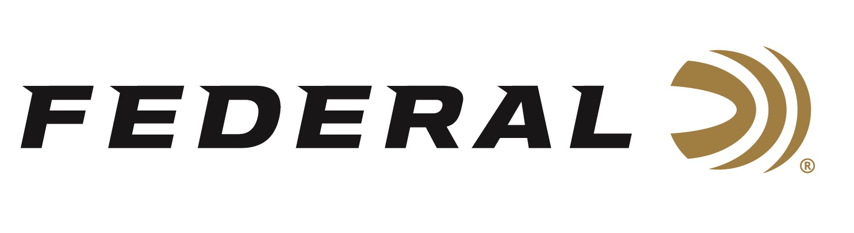
FOR IMMEDIATE RELEASE

Federal Ammunition Sponsored Shooters Shine at the 2026 NSCA Western Regional Championships

ANOKA, Minnesota – March 25, 2026 – The 2026 National Sporting Clays Association (NSCA) Western Regional Championships, held March 16–22 at Coyote Springs Sporting Clays in Tucson, Arizona, recently wrapped up with standout performances from several sponsored Federal Ammunition shooters. The event had 625 shooters.

Derrick Mein finished as the FITASC High Over All (HOA) Champion with a score of 97 out of 100 targets. He was also the HOA Runner-Up in the Main Event and the Runner-Up in 5-Stand. Jonathan Prince was Junior Main Event Champion with a score of 188 out of 200 targets. He was also the Junior 5-Stand Runner-Up.

“Under tough conditions with high temperatures and stout competition, my combination of HOA and Gold Medal Paper proved to be the difference against my competitors,” said Derrick Mein. “I feel like I had one of my best performances and attribute that success to my confidence in my equipment.”

“These athletes are true competitors,” said Federal’s Vice President of Marketing Jason Nash. “We know that talents of this level must trust the best equipment available, and we are proud to have them as part of Team Federal.”

Federal is the number one choice for shotgun shells and manufactures product in America for all competitive and recreational disciplines. See the full lineup, including the brand's latest and greatest target loads: High Over All, Gold Medal Paper,
and Master Class.

Federal Ammunition products are available at dealers nationwide and online. For more information on all Federal products and to sign up for notifications about new product availability, rebate promotions, and other brand news via email, visit www.federalpremium.com.

Press Release Contact: JJ Reich
Senior Manager – Press Relations
E-mail: media@tkghunt.com

About Federal Ammunition
Federal, headquartered in Anoka, MN, is an ammunition brand of The Kinetic Group, owned by CSG, a globally diversified industrial group based in Prague, Czech Republic. Since 1922, Federal has been a leader in ammunition innovation, delivering high-quality sporting and hunting products to shooters worldwide. With a commitment to conservation and the outdoor community, Federal continues to manufacture industry-leading ammunition that enhances the shooting experience while supporting outdoor traditions.

