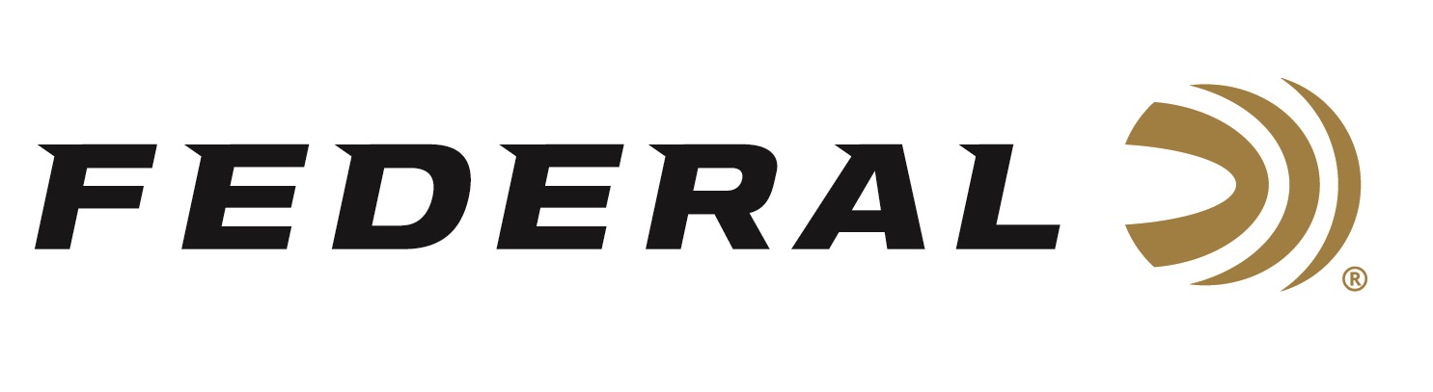

FOR IMMEDIATE RELEASE

Federal Signs Landmark Agreement with U.S. Army to Accelerate High-Performance Ammunition

ANOKA, Minnesota – May 27, 2026 – Federal Ammunition today announced it has executed an agreement that allows the United States Army to utilize its patented Peak Alloy ammunition case technology for use in multiple cartridges and weapon systems.
The new agreement specifies conditions necessary prior to granting Government Purpose Rights, such as the delivery of 40 million cases featuring technology.

Peak Alloy was first introduced in the commercial market in 2025 with the all new 7mm Backcountry. It is a high-strength, proprietary steel alloy casing that enables significantly higher chamber pressure — in excess of 80,000 PSI — than traditional brass for higher velocities in smaller, lighter, shorter-barreled rifles typically configured for suppressors. This case technology is also being evaluated by multiple allied European countries.

The agreement with the U.S. Army is inclusive of multiple chamberings including 50-cal and below.

“This is a historic agreement between the United States military and Federal Ammunition,” says Chairman and CEO Jason Vanderbrink. “As a 104-year-old American company, it further demonstrates our unwavering commitment to innovation. As the world’s most prominent manufacturer of small-caliber ammunition, I am particularly proud of the speed at which our team can develop a product with a purposeful application that improves the advanced systems our brave American warfighters use in the field of battle,” said Vanderbrink.

Federal Ammunition products are available at dealers nationwide and online. For more information on all Federal products and to sign up for notifications about new product availability, rebate promotions, and other brand news via email, visit www.federalpremium.com.

Press Release Contact: JJ Reich
Senior Manager – Press Relations
E-mail: media@tkghunt.com

About Federal Ammunition
Federal, headquartered in Anoka, MN, is an ammunition brand of The Kinetic Group, owned by CSG, a globally diversified industrial group based in Prague, Czech Republic. Since 1922, Federal has been a leader in ammunition innovation, delivering high-quality sporting and hunting products to shooters worldwide. With a commitment to conservation and the outdoor community, Federal continues to manufacture industry-leading ammunition that enhances the shooting experience while supporting outdoor traditions.

