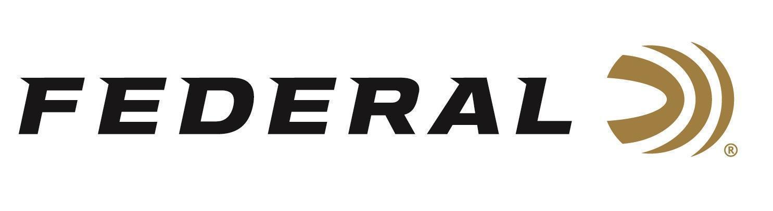

FOR IMMEDIATE RELEASE

New Federal Fit Firearm Covers Now Shipping
ANOKA, Minnesota – July 1, 2026 – Federal Ammunition is now shipping two new series of firearm covers, the Federal Fit Coil Rifle Cover and Federal Fit Quick Strike Muzzle/Scope Cover. Each is available in medium, large, and extra-large.

The Federal Fit Coil Rifle Cover delivers superior protection while at the range or in the field. It features a roll-up design that lets shooters adjust case length to the firearm and is equipped with a quick-grab handle. It is suppressor-ready, meaning the muzzle area inside the cover has heat-resistant lining. Sizes include medium for firearms of 34 to 44 inches in length, large for 39 to 49 inches, and XL for 44 to 54 inches.

“With a roll-up design that lets shooters adjust case length to the firearm, our Federal Fit Coil Rifle Cover is a suppressor-ready rifle case that is ready for anything,” explains Jake Jacobs, Federal’s Accessories Product Director. “It has a heat-resistant lining in the muzzle area and a quick-grab handle. With suppressors being so wildly popular these days, having the gear needed to protect them properly and conveniently is an absolute necessity.”

Learn more at: Federal Fit Coil Rifle Cover.

Federal’s Adjustable-fit scope and muzzle cover protect the scope and muzzle at the range or in the field. It is suppressor-ready, meaning the muzzle area inside the cover has heat-resistant lining, yet it can accommodate unsuppressed rifles as well. Sizes include medium for lengths of 24 to 30 inches, large for 27 to 33 inches, and XL for 30 to 36 inches.

“Our new Federal Fit Quick Strike Cover keeps your scope and muzzle clear and protected with this fast-deploying cover,” continued Jacobs, Federal’s Accessories Product Director. “It features a convenient stretch-fit design, and it’s ideal to keep your scope and muzzle covered while your firearm is connected to a pack, ATV, UTV, e-bike, or the gun rack inside the truck,” he said.

Learn more at: Federal Fit Quick Strike Cover.

Part No. / Description / MSRP
FFCOILM / Federal Fit Coil Rifle Cover, Medium / $59.99
FFCOILL / Federal Fit Coil Rifle Cover, Large / $59.99
FFCOILXL / Federal Fit Coil Rifle Cover, X-Large / $59.99
FFQSM / Federal Fit Quick Strike Muzzle/Scope Cover, Medium / $49.99
FFQSL / Federal Fit Quick Strike Muzzle/Scope Cover, Large / $49.99
FFQSXL / Federal Fit Quick Strike Muzzle/Scope Cover, X-Large / $49.99
Federal Ammunition products are available at dealers nationwide and online. For more information on all Federal products and to sign up to receive notifications about new product availability, rebate promotions, and other brand news via email, visit www.federalpremium.com.

Press Release Contact: JJ Reich
Senior Manager – Press Relations
E-mail: media@tkghunt.com

About Federal Ammunition
Federal, headquartered in Anoka, MN, is an ammunition brand of The Kinetic Group, owned by CSG, a globally diversified industrial group based in Prague, Czech Republic. Since 1922, Federal has been a leader in ammunition innovation, delivering high-quality sporting and hunting products to shooters worldwide. With a commitment to conservation and the outdoor community, Federal continues to manufacture industry-leading ammunition that enhances the shooting experience while supporting outdoor traditions.

