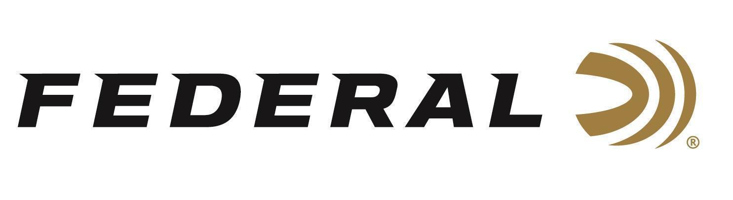

FOR IMMEDIATE RELEASE

New Federal Fit Pursuit Rifle Case Now Shipping
ANOKA, Minnesota – February 19, 2026 – Federal Ammunition is now shipping its new Federal Fit Pursuit Rifle Case, designed to protect and transport modern rifles, including those equipped with suppressors. This new adjustable fit scoped rifle case delivers an adaptable fit, suppressor protection, and other field-friendly features that help shooters stay organized and keep their gear protected at the range or in the field.
Federal Fit Pursuit Rifle Case
“Today’s shooters are running a wide range of rifle setups, and we built these Federal Fit accessories to match that reality,” said Jake Jacobs, Federal’s Accessories Product Director. “From suppressor-ready heat-resistant protection to adjustable fit and smart storage, the Pursuit Rifle Case helps keep rifles secure, protected, and ready to go wherever the day takes you.”
The Federal Fit Pursuit Rifle Case features an adjustable roll up design that lets shooters customize case length to fit rifles with or without suppressors. It includes heat resistant lining in the muzzle area and offers multiple pockets, adjustable straps, and carry options for more convenient transport and storage. The case also features a dual zipper drop in entry, quick grab carry handle, and a double shoulder strap that allows shooters to backpack the firearm when moving through the field or range.
Part No. / Description / MSRP
FAFSRC40 / Pursuit Adjustable Fit Scoped Rifle Case, 40 inch, Black / $139.99
FAFSRC45 / Pursuit Adjustable Fit Scoped Rifle Case, 45 inch, Black / $139.99
Federal Ammunition products are available at dealers nationwide and online. For more information on all Federal products and to sign up to receive notifications about new product availability, rebate promotions, and other brand news via email, visit www.federalpremium.com.

Press Release Contact: JJ Reich
Senior Manager – Press Relations
E-mail: media@tkghunt.com

About Federal Ammunition
Federal, headquartered in Anoka, MN, is an ammunition brand of The Kinetic Group, owned by CSG, a globally diversified industrial group based in Prague, Czech Republic. Since 1922, Federal has been a leader in ammunition innovation, delivering high-quality sporting and hunting products to shooters worldwide. With a commitment to conservation and the outdoor community, Federal continues to manufacture industry-leading ammunition that enhances the shooting experience while supporting outdoor traditions.

