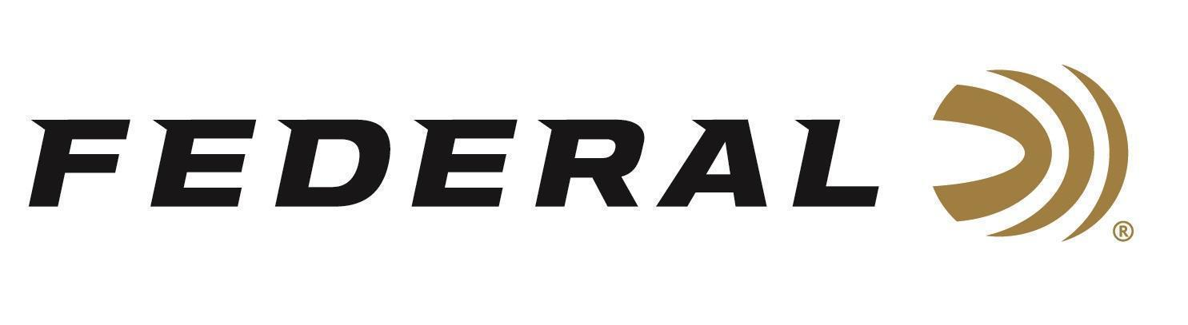

FOR IMMEDIATE RELEASE

New, Unique Suppressor Case from Federal Now Shipping
ANOKA, Minnesota – June 15, 2026 – Federal Ammunition is now shipping its new Suppressor Case, designed to keep suppressors safe and secure when not in use with this rugged case. Its heat-resistant lining and side-pinch pockets make it easy to store and remove a hot suppressor after shooting at the range. The case opens and closes fast with a full-length zipper and T-handle.

Federal Suppressor Case

“Modern shooters are running suppressors more today than ever before,” said Jake Jacobs, Federal’s Accessories Product Director. “Our unique Suppressor Case helps keep cans secure, protected, and ready to go wherever the day takes you. Its convenient design also acts like an oven mitt to help take a suppressor off a rifle easily, even when it’s still piping hot. Any shooter not patient to wait for their can to cool off will love that feature, I certainly do!”

Federal’s new Suppressor Case is sized to fit common rifle, handgun, and shotgun suppressors, accommodating suppressor lengths up to 10 inches long. It comes in a Coyote Tan color and features rugged materials plus a zippered storage pocket.

Part No. / Description / MSRP
FHGCCTAN / Federal Suppressor Case, Rifle/Handgun/Shotgun, 10 inches / $39.99
Federal Ammunition products are available at dealers nationwide and online. For more information on all Federal products and to sign up to receive notifications about new product availability, rebate promotions, and other brand news via email, visit www.federalpremium.com.

Press Release Contact: JJ Reich
Senior Manager – Press Relations
E-mail: media@tkghunt.com

About Federal Ammunition
Federal, headquartered in Anoka, MN, is an ammunition brand of The Kinetic Group, owned by CSG, a globally diversified industrial group based in Prague, Czech Republic. Since 1922, Federal has been a leader in ammunition innovation, delivering high-quality sporting and hunting products to shooters worldwide. With a commitment to conservation and the outdoor community, Federal continues to manufacture industry-leading ammunition that enhances the shooting experience while supporting outdoor traditions.

