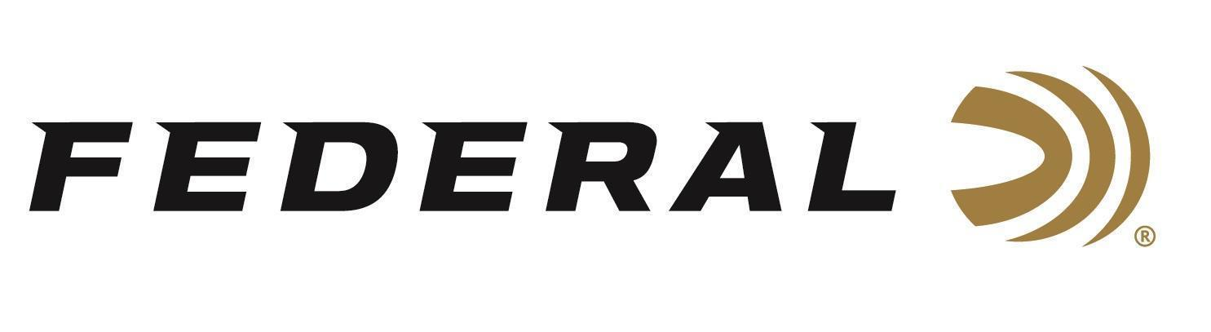

FOR IMMEDIATE RELEASE
Federal’s New Champion Training 9mm Handgun Loads Now Shipping
ANOKA, Minnesota – March 31, 2026 – Federal Ammunition is currently shipping several new Champion Training handgun loads. Built for volume shooters who demand consistent accuracy and reliable function at an affordable price, these new options are now being delivered to retailers nationwide and expand the existing Champion handgun product line.
Champion Training
“Champion Training loads are designed to give shooters the dependable performance they need for high-volume range time,” said Federal’s Handgun Product Manager Chriss Laack. “With quality components and consistent results, these new additions make it even easier for customers to stock up on trusted training ammunition across the most popular handgun calibers.”
Federal Champion handgun loads provide accurate, target-grade performance and are loaded with reliable brass and primers to ensure consistent ignition and smooth cycling. Ideal for target practice and training, Champion delivers the kind of dependable performance shooters count on at a price built for frequent range use.
Part No. / Description / MSRP
C9124A / 9mm Luger, 124-grain FMJ Champion Brass, 50 Round-Box / $18.99
C9124A200 / 9mm Luger, 124-grain FMJ Champion Brass, 200 Round-Box / $76.99
Federal Ammunition products are available at dealers nationwide and online. For more information on all Federal products and to sign up to receive notifications about new product availability, rebate promotions, and other brand news via email, visit www.federalpremium.com.

Press Release Contact: JJ Reich
Senior Manager – Press Relations
E-mail: media@tkghunt.com

About Federal Ammunition
Federal, headquartered in Anoka, MN, is an ammunition brand of The Kinetic Group, owned by CSG, a globally diversified industrial group based in Prague, Czech Republic. Since 1922, Federal has been a leader in ammunition innovation, delivering high-quality sporting and hunting products to shooters worldwide. With a commitment to conservation and the outdoor community, Federal continues to manufacture industry-leading ammunition that enhances the shooting experience while supporting outdoor traditions.

