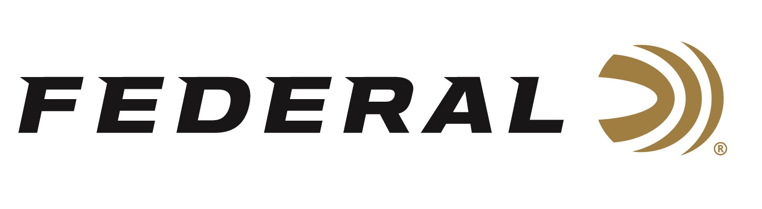

FOR IMMEDIATE RELEASE

Federal Wins Predator Xtreme 2026 Gold Award for Best Shotshells

ANOKA, Minnesota – February 4, 2026 – Federal has received the 2026 Gold Award in the Shotshells category from the Predator Xtreme readers. Hunters who read this magazine are incredibly loyal to the products they use, and these annual awards allow them to reveal what products they think are the absolute best.

“The Predator Xtreme Readers' Choice Awards have been going strong since 2012, and very few brands have shone as bright as Federal, earning gold honors 9 times out of 14 years and now 8 years in a row,” said Predator Xtreme Publisher Derrick Nawrocki. “Federal has proven their Shotshells have phenomenal take-down power in the field, and clearly our readers are huge fans of Federal’s shotgun shells."

Predator Xtreme polled its readership to find out their favorite gear—the products that really work. They then tallied the votes to determine the 2026 Readers' Choice Awards. The awards represent the best insider knowledge on products proven to work best for hunters nationwide. Reporting this knowledge helps their readers become better hunters and spend their hunting gear money wisely.

“Federal has long been a fan favorite and continues to be the consistent brand predator hunters trust, year after year,” said Federal Shotshell Product Director Dan Compton. “Our Federal Premium Buckshot 4B (P158 4B) is an excellent choice for diehard hunters. We engineer these buckshot shotshells to perform with the same precision as all our other shotshell loads. This load uses copper-plated pellets to produce tight patterns and great downrange energy. It also puts more hits on target for impressive stopping power on predators, hogs, and deer.”

To learn more about new products from Federal Ammunition for 2026, visit New Products | Federal Premium.

Federal Ammunition products are available at dealers nationwide and online. For more information on all Federal products and to sign up for notifications about new product availability, rebate promotions, and other brand news via email, visit www.federalpremium.com.

Press Release Contact: JJ Reich
Senior Manager – Press Relations
E-mail: media@tkghunt.com

About Federal Ammunition
Federal, headquartered in Anoka, MN, is an ammunition brand of The Kinetic Group, owned by CSG, a globally diversified industrial group based in Prague, Czech Republic. Since 1922, Federal has been a leader in ammunition innovation, delivering high-quality sporting and hunting products to shooters worldwide. With a commitment to conservation and the outdoor community, Federal continues to manufacture industry-leading ammunition that enhances the shooting experience while supporting outdoor traditions.

