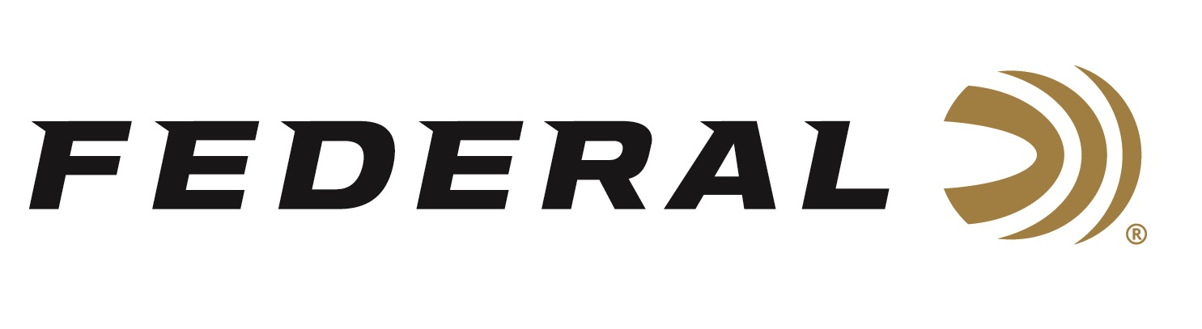

FOR IMMEDIATE RELEASE

Federal Expands Its All-American Target Load Lineup with New Options for 2026

ANOKA, Minnesota – January 14, 2026 – Federal Ammunition expands its all-new shotshell product line: Federal All-American. These competition-level trap and skeet loads feature a customized Podium wad that extracts peak performance from utilizing Federal’s straight-wall hull, reliable primers, high-antimony lead shot, and select propellant. The thirteen competition load options include eleven 2-3/4-inch, 12-gauge loads ranging from 1 ounce to 1-1/8 ounce in 7.5, 8, or 9 shot. And the two 2-3/4-inch, 20-gauge loads are 7/8-ounce in 7.5 or 8 shot.

All-American features a one-piece Podium wad and high-antimony lead shot that balances hardness and density. The loads are constructed with a straight-wall hull, an inserted plastic base wad, and a striated tube for optimum performance. All-American offers a much better option than standard target loads for competitors in trap and skeet. They feature high-quality components in an ultra-reliable two-piece straight wall hull design. All-American is offered in the most popular payloads and velocities for modern trap and skeet competitions and is packaged in 25-count boxes.

The products will be displayed at the 2026 SHOT Show, January 20–23 at the Venetian Expo and Caesars Forum in Las Vegas, Nevada. Attendees of the show are encouraged to stop by Booth No. 11838 for a first-hand look at these new products and more.

Information about the new products for 2026 can be found on Federal’s brand website soon after the SHOT Show. Sign up to receive exclusive access to online promotions and news via email by visiting Federal Ammunition - Sign Up.

Federal Ammunition products are available at dealers nationwide and online. For more information on all Federal products and to sign up for notifications about new product availability, rebate promotions, and other brand news via email, visit www.federalpremium.com.

Press Release Contact: JJ Reich
Senior Manager – Press Relations
E-mail: media@tkghunt.com
About Federal Ammunition
Federal, headquartered in Anoka, MN, is an ammunition brand of The Kinetic Group, owned by CSG, a globally diversified industrial group based in Prague, Czech Republic. Since 1922, Federal has been a leader in ammunition innovation, delivering high-quality sporting and hunting products to shooters worldwide. With a commitment to conservation and the outdoor community, Federal continues to manufacture industry-leading ammunition that enhances the shooting experience while supporting outdoor traditions.

