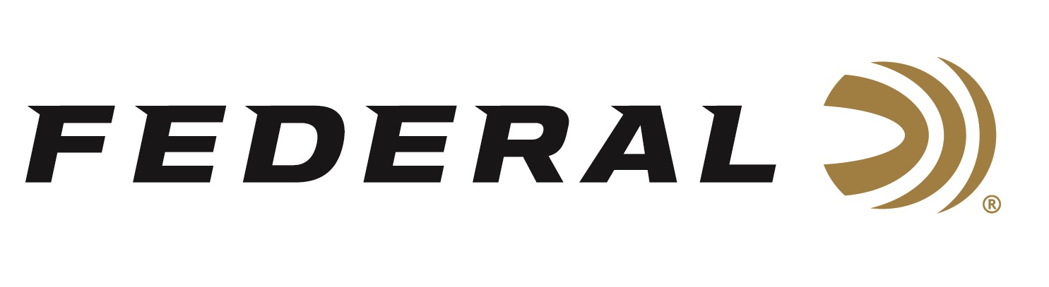

FOR IMMEDIATE RELEASE

Federal Will Release More Than 20 New Centerfire Rifle Ammo Options in 2026

ANOKA, Minnesota – January 7, 2026 – Federal Ammunition announces several new centerfire rifle ammunition options for 2026. A new product line, Federal Subsonic, will be introduced, along with many new additions to existing product lines, including Terminal Ascent, Berger Elite Hunter, Fusion Tipped, and several more.

The Federal Subsonic new product line comprises four cartridge options designed for peak noise reduction and effective low-velocity expansion through suppressors. The new loads are Fusion 30-30 Win. 170-grain, Fusion 45-70 Govt. 300-grain, Fusion Tipped 308 Win. 190-grain, and 300 Blackout 190-grain.

Federal Premium® Terminal Ascent bonded construction bullets feature high ballistic coefficients and nickel plating, plus the patented Slipstream® polymer tip initiates expansion. The two new loads are 6.5mm PRC 140-grain and 300 Rem. Ultra Mag. 175-grain.

The Berger Elite Hunter thin-jacketed hunting bullet touts a high ballistic coefficient and is loaded with Premium components to incredibly tight tolerances. The loads produce lethal accuracy at extended distances. The new load is 7mm PRC 195-grain.

The 6mm ARC (Advanced Rifle Cartridge) is designed for the AR-15 platform, offering low recoil and high accuracy for long-range shooting. The three new loads from Federal include American Eagle TMJ 110-grain, Fusion Tipped 110-grain, Gold Medal Berger BT Target 108-grain.

In collaboration with Henry Repeating Arms, Federal’s Golden Boy Collector’s Edition is rifle loads packed in commemorative, collectible packaging. It pairs with Henry’s 250th anniversary U.S.A. edition of its iconic Golden Boy lever-action centerfire rifle. The new product is 45-70 Govt. 300-gr Jacketed Soft Point (JSP).

These all-new centerfire rifle products, and more, will be on display at the 2026 SHOT Show, January 20–23 at the Venetian Expo and Caesars Forum in Las Vegas, Nevada. Attendees of the show are encouraged to stop by Booth No. 11838 for a first-hand look at these new products.

Information about the new products for 2026 can be found on Federal’s brand website soon after the SHOT Show. Sign up to receive exclusive access to online promotions and news via email by visiting Federal Ammunition - Sign Up.

Federal Ammunition products are available at dealers nationwide and online. For more information on all Federal products and to sign up for notifications about new product availability, rebate promotions, and other brand news via email, visit www.federalpremium.com.

Press Release Contact: JJ Reich
Senior Manager – Press Relations
E-mail: media@tkghunt.com

About Federal Ammunition
Federal, headquartered in Anoka, MN, is an ammunition brand of The Kinetic Group, owned by CSG, a globally diversified industrial group based in Prague, Czech Republic. Since 1922, Federal has been a leader in ammunition innovation, delivering high-quality sporting and hunting products to shooters worldwide. With a commitment to conservation and the outdoor community, Federal continues to manufacture industry-leading ammunition that enhances the shooting experience while supporting outdoor traditions.

