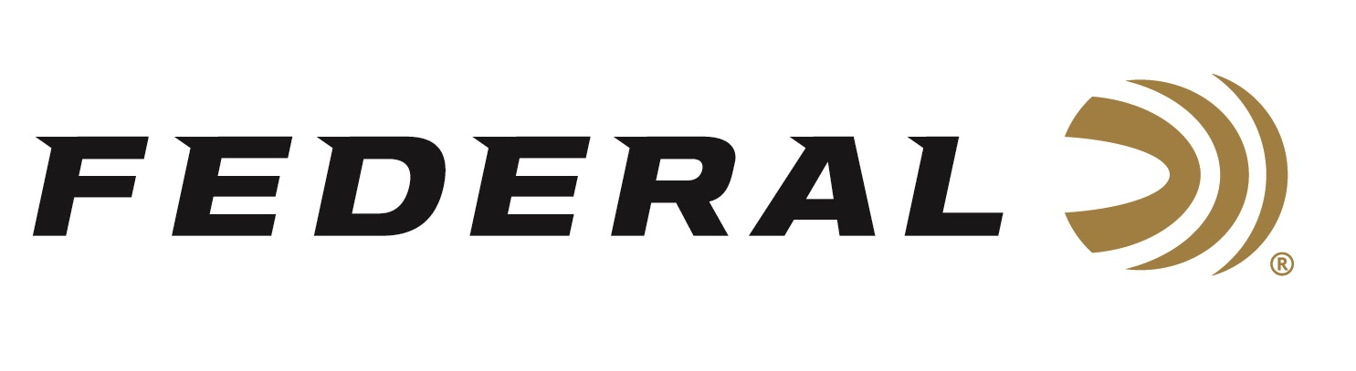

FOR IMMEDIATE RELEASE

Texas Parks and Wildlife Commission Approves Federal’s FireStick Technology

ANOKA, Minnesota – April 8, 2026 – Texas has officially approved the use of the Federal Premium FireStick system and compatible rifles, such as the Traditions NitroFire, CVA Crossfire, and Thompson/Center Encore, for its upcoming muzzleloader hunting seasons. The Texas Parks and Wildlife Commission recently approved this change in March 2026, effective for the 2026-2027 hunting season.

“We applaud Texas for changing its definition of a muzzleloader, expanding it to include newer technology where the powder is encased and charged from the breech, while the projectile is still loaded through the muzzle,” said Jon Zinnel, Federal Ammunition’s Director of Community Relations. “The update aims to provide hunters with more reliable and safer equipment options, particularly in damp or rainy conditions where traditional loose powder can be compromised.”

Federal’s FireStick is a patented muzzleloading propellant system that is safer and easier to use than traditional 209 inline muzzleloader systems. The primary benefits of the FireStick are best-in-class safety, followed by convenience, consistent accuracy, ease of cleaning, and simplicity of use.

Learn more at: FireStick (federalpremium.com).

“Arizona also recently added the Firestick to its list of legal firearms for muzzleloading hunting,” continued Zinnel. “Now, with 30-plus states, more than half of the United States has legalized this revolutionary muzzleloader ignition system.”

Hunters will also continue to see an affiliation with the Congressional Sportsmen’s Foundation, which has been instrumental in the legislative process to authorize the new FireStick in many states. This partnership will raise awareness of this important organization and support its dedication to protecting and enhancing the way of life of hunters, anglers, recreational shooters, and trappers nationwide.
Federal Ammunition products are available at dealers nationwide and online. For more information on all Federal products and to sign up to receive notifications about new product availability, rebate promotions, and other brand news via email, visit www.federalpremium.com.

Press Release Contact: JJ Reich
Senior Manager – Press Relations
E-mail: media@tkghunt.com

About Federal Ammunition
Federal, headquartered in Anoka, MN, is an ammunition brand of The Kinetic Group, owned by CSG, a globally diversified industrial group based in Prague, Czech Republic. Since 1922, Federal has been a leader in ammunition innovation, delivering high-quality sporting and hunting products to shooters worldwide. With a commitment to conservation and the outdoor community, Federal continues to manufacture industry-leading ammunition that enhances the shooting experience while supporting outdoor traditions.

