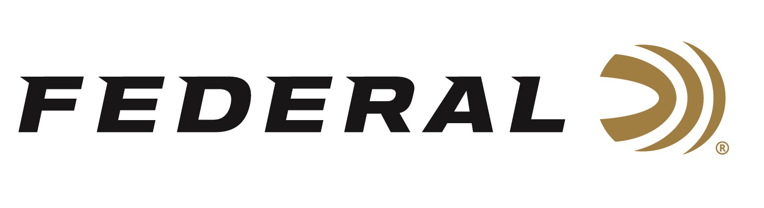

FOR IMMEDIATE RELEASE

Federal Will Release More Than Six New Handgun Ammo Options in 2026

ANOKA, Minnesota – January 9, 2026 – Federal Ammunition announces new handgun ammunition options for 2026. Two new offerings will be added to the Power-Shok hunting handgun and Punch Personal Defense product lines. The world-leading ammunition brand will also launch an all-new Federal Premium® Terminal Ascent hunting handgun product line.

Three Terminal Ascent handgun-hunting rounds feature a bonded, nickel-plated bullet design to increase weight retention, while a unique elastomer-filled nose cavity reliably expands. The new loads include 10mm Auto 203-grain, 357 Mag. 157-grain, and 44 Rem. Mag. 235-grain.

The Power-Shok handgun-hunting round features a powerful, standard jacketed hollow-point bullet suited to a variety of big game and offered at a specific price point. The new load is 45 Long Colt 235-grain.

The bullet for the Punch Personal Defense load is carefully selected and built to optimize terminal performance in the most common situations. The new defensive handgun load is 9mm Luger 115-grain.

These all-new products, and more, will be on display at the 2026 SHOT Show, January 20–23 at the Venetian Expo and Caesars Forum in Las Vegas, Nevada. Attendees of the show are encouraged to stop by Booth No. 11838 for a first-hand look at these new products and more.

Information about the new products for 2026 can be found on Federal’s brand website soon after the SHOT Show. Sign up to receive exclusive access to online promotions and news via email by visiting Federal Ammunition - Sign Up.

Federal Ammunition products are available at dealers nationwide and online. For more information on all Federal products and to sign up for notifications about new product availability, rebate promotions, and other brand news via email, visit www.federalpremium.com.

Press Release Contact: JJ Reich
Senior Manager – Press Relations
E-mail: media@tkghunt.com

About Federal Ammunition
Federal, headquartered in Anoka, MN, is an ammunition brand of The Kinetic Group, owned by CSG, a globally diversified industrial group based in Prague, Czech Republic. Since 1922, Federal has been a leader in ammunition innovation, delivering high-quality sporting and hunting products to shooters worldwide. With a commitment to conservation and the outdoor community, Federal continues to manufacture industry-leading ammunition that enhances the shooting experience while supporting outdoor traditions.

