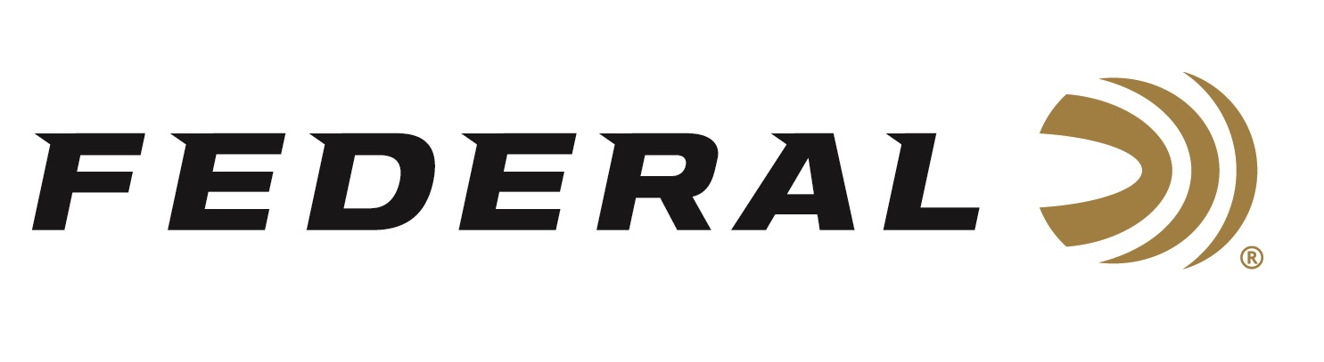

FOR IMMEDIATE RELEASE

Federal Will Release More Than 25 New Shotshell Options in 2026

ANOKA, Minnesota – January 8, 2026 – Federal Ammunition will launch more than twenty-five new shotshell ammunition offerings in 2026. This includes two all-new ammunition product lines which are Rob Roberts Raptor and All-American. Plus, several Realtree 40th Anniversary Special Edition turkey loads will be offered for the upcoming spring hunting seasons.

Rob Roberts Raptor waterfowl loads extract the tightest, most efficient patterns from Rob Roberts Raptor Series chokes. The new loads are 2-3/4-inch, 12-gauge, 1-3/8-ounce, 1400-fps in 2, 3, or 4 shot, and 3-inch, 20-gauge, 1-ounce, 1400-fps in 2, 3, or 4 shot.

All-American competition Trap and Skeet loads use a Podium™ wad customized for straight-wall hulls and are trusted by the world’s best competitive shooters. The twelve new 2-3/4-inch, 12-gauge loads range from 1 ounce to 1-1/8 ounce in 7.5, 8, or 9 shot. The 2-3/4-inch, 20-gauge load is 7/8-ounce in 7.5 or 8 shot.

Federal is helping Realtree celebrate four decades of camouflage design and innovation with five turkey loads in commemorative packaging. Two Grand Slam lead loads are 3-inch, 12-gauge, and 20-gauge in No. 5 shot. The Realtree 40th Anniversary Special Edition comprises three HEAVYWEIGHT TSS loads: 3-inch, 12-gauge, 20-gauge, and 410-bore in No. 9 shot.

These all-new products, and more, will be on display at the 2026 SHOT Show, January 20–23 at the Venetian Expo and Caesars Forum in Las Vegas, Nevada. Attendees of the show are encouraged to stop by Booth No. 11838 for a first-hand look at these new products and more.

Information about the new products for 2026 can be found on Federal’s brand website soon after the SHOT Show. Sign up to receive exclusive access to online promotions and news via email by visiting Federal Ammunition - Sign Up.

Federal Ammunition products are available at dealers nationwide and online. For more information on all Federal products and to sign up for notifications about new product availability, rebate promotions, and other brand news via email, visit www.federalpremium.com.

Press Release Contact: JJ Reich
Senior Manager – Press Relations
E-mail: media@tkghunt.com

About Federal Ammunition
Federal, headquartered in Anoka, MN, is an ammunition brand of The Kinetic Group, owned by CSG, a globally diversified industrial group based in Prague, Czech Republic. Since 1922, Federal has been a leader in ammunition innovation, delivering high-quality sporting and hunting products to shooters worldwide. With a commitment to conservation and the outdoor community, Federal continues to manufacture industry-leading ammunition that enhances the shooting experience while supporting outdoor traditions.

