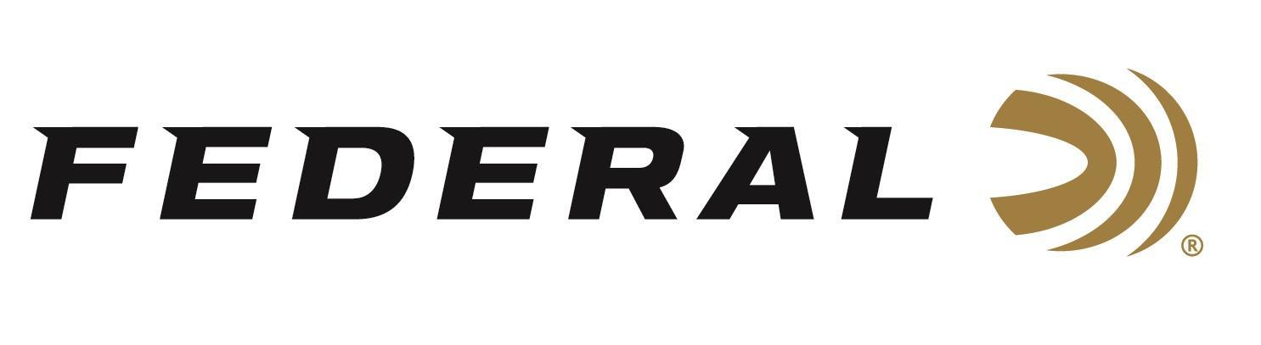

FOR IMMEDIATE RELEASE
Federal X Henry Birthday Boy Collector’s Edition Ammunition Now Shipping
ANOKA, Minnesota – April 3, 2026 – Federal Ammunition has officially begun shipping its Federal X Henry Collector’s Edition ammunition, created in partnership with legendary U.S. firearm manufacturer Henry Repeating Arms. This limited-edition load was developed for Henry’s commemorative 45-70 Government Golden Boy lever-action rifle, touted as the Birthday Boy. It celebrates America’s 250th anniversary with a unique offering built for both collectors and shooters.
Federal X Henry 250th Anniversary
“It’s a landmark moment in American history, and this collaboration celebrates that heritage in a meaningful way,” said Federal’s Centerfire Rifle Ammunition Director, Mike Holm. “The Henry Birthday Boy is a specialized version of their iconic Golden Boy lever-action rifle. By pairing their America’s 250th commemorative rifle with our special-edition collector’s load, we’re giving collectors and shooters ammunition that honors the past while delivering the performance they expect.”
The Federal X Henry Collector’s Edition load is chambered in the classic 45-70 Government cartridge and features a 300-grain Hollow Point bullet for accurate, reliable performance at the range or in the field. In addition to its collectible packaging, the ammunition is loaded with top-quality Federal brass and primers to ensure consistent function and trusted performance.
Part No. / Description / MSRP
4570HENRY / 45-70 Government, 300-grain HP, 1,850 fps / 20-count / $74.99
Federal Ammunition products are available at dealers nationwide and online. For more information on all Federal products and to sign up to receive notifications about new product availability, rebate promotions, and other brand news via email, visit www.federalpremium.com.

Press Release Contact: JJ Reich
Senior Manager – Press Relations
E-mail: media@tkghunt.com

About Federal Ammunition
Federal, headquartered in Anoka, MN, is an ammunition brand of The Kinetic Group, owned by CSG, a globally diversified industrial group based in Prague, Czech Republic. Since 1922, Federal has been a leader in ammunition innovation, delivering high-quality sporting and hunting products to shooters worldwide. With a commitment to conservation and the outdoor community, Federal continues to manufacture industry-leading ammunition that enhances the shooting experience while supporting outdoor traditions.

