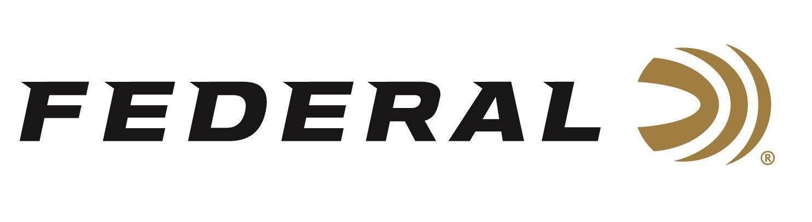

FOR IMMEDIATE RELEASE
Federal’s New Heavyweight TSS Rob Roberts Limited Edition Loads Now Shipping
ANOKA, Minnesota – March 26, 2026 – Federal Ammunition has officially begun shipping its new Heavyweight TSS Rob Roberts Limited Edition turkey loads. Developed in collaboration with legendary choke designer Rob Roberts, these limited-edition offerings deliver the extreme range, pattern density, and lethal energy serious turkey hunters demand.
HEAVYWEIGHT TSS Rob Roberts
“Rob Roberts has built his reputation on helping hunters get the most out of their turkey setups, and these limited-edition loads reflect that same pursuit of performance,” said Dan Compton, Federal’s Shotshell Product Line Director, “By pairing Federal Premium Heavyweight TSS with his personal favorite shot sizes and our proven FLITECONTROL FLEX wad, we’re delivering a turkey load built for tight patterns, long-range power, and confidence when the shot matters most.”
These powerful, limited-edition loads are offered in both No. 7 and No. 9 shot, two of Roberts’ personal favorites. The No. 7 payload is engineered for an ideal balance of pattern efficiency and long-range power to flatten hung-up gobblers, while the No. 9 option maximizes pellet counts for the ultimate pattern density. Like all Federal Premium Heavyweight TSS ammunition, these loads feature 18 g/cc tungsten-alloy shot that is 56 percent denser than lead for exceptional energy and the highest pellet counts at extreme range.
To maximize pattern consistency, the loads utilize the rear-braking FLITECONTROL FLEX wad, which performs reliably through both ported and standard turkey chokes. A roll crimp and clear card wad help keep advanced buffering material in place, while full-length wads prevent direct contact between the extra-hard pellets and the bore to protect the barrel.
Part No. / Description / MSRP
PTSSX198FRR7 / 12-ga., 3-in. 2-oz., No. 7, HWT TSS / 5-count / $111.99
PTSSX198FRR9 / 12-ga., 3-in., 2-oz., No. 9, HWT TSS / 5-count / $97.99
PTSSX295FRR7 / 20-ga., 3-in., 1-5/8-oz., No. 7, HWT TSS / 5-count / $111.99
PTSSX295FRR9 / 20-ga., 3-in., 1-5/8-oz., No. 9 HWT TSS / 5-count / $97.99

Federal Ammunition products are available at dealers nationwide and online. For more information on all Federal products and to sign up to receive notifications about new product availability, rebate promotions, and other brand news via email, visit www.federalpremium.com.

Press Release Contact: JJ Reich
Senior Manager – Press Relations
E-mail: media@tkghunt.com

About Federal Ammunition
Federal, headquartered in Anoka, MN, is an ammunition brand of The Kinetic Group, owned by CSG, a globally diversified industrial group based in Prague, Czech Republic. Since 1922, Federal has been a leader in ammunition innovation, delivering high-quality sporting and hunting products to shooters worldwide. With a commitment to conservation and the outdoor community, Federal continues to manufacture industry-leading ammunition that enhances the shooting experience while supporting outdoor traditions.

