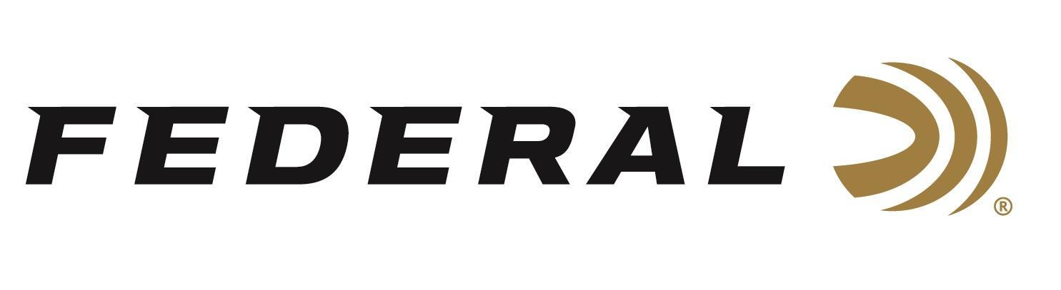

FOR IMMEDIATE RELEASE

Federal Ammunition Launches Henry Cattleman Special Edition
ANOKA, Minnesota – February 3, 2026 – Federal Ammunition launches a limited-edition, commemorative, collectible packaging to pair with Henry’s American Cattleman Tribute Edition Rifle. The new 150-grain, 30-30 Win. offering features a bonded soft-point bullet, and the nickel-plated case’s unique geometry ensures smooth, reliable feeding through the rifle.
“Whether you’re looking to hunt deer, hogs, and other big game, or just channel your inner cowboy, Federal and Henry Repeating Arms have the combination you need,” said Federal’s Marketing Director Brian Anderson. “The two iconic brands have collaborated on a new load for Henry’s American Cattleman lever-action rifle. We, at Federal, are excited about this collaboration.”
This new product, designed in collaboration with Henry Repeating Arms for its American Cattleman rifle, boasts a muzzle velocity of 2,390 fps. It features a bonded soft-point bullet that expands reliably and penetrates deep. The nickel-plated case is specially designed for more reliable feeding in lever-action rifles. It is packaged in 20-count boxes and is made in the USA.

This new product will be on display at the Henry Repeating Arms booth at CattleCon 2026. This event is the Cattle Industry Convention and the National Cattlemen's Beef Association’s (NCBA) Trade Show. The event is at the Music City Center in downtown Nashville, Tennessee, from February 3-5, 2026.

To learn more about Federal’s Cattleman Edition ammunition and all the new products from Federal Ammunition for 2026, visit New Products | Federal Premium. To learn more about the Henry’s rifle, visit American Cattleman Tribute Edition Rifle | Henry Repeating Arms.

Federal Ammunition products are available at dealers nationwide and online. For more information on all Federal products and to sign up for notifications about new product availability, rebate promotions, and other brand news via email, visit www.federalpremium.com.

Press Release Contact: JJ Reich
Senior Manager – Press Relations
E-mail: media@tkghunt.com

About Federal Ammunition
Federal, headquartered in Anoka, MN, is an ammunition brand of The Kinetic Group, owned by CSG, a globally diversified industrial group based in Prague, Czech Republic. Since 1922, Federal has been a leader in ammunition innovation, delivering high-quality sporting and hunting products to shooters worldwide. With a commitment to conservation and the outdoor community, Federal continues to manufacture industry-leading ammunition that enhances the shooting experience while supporting outdoor traditions.

