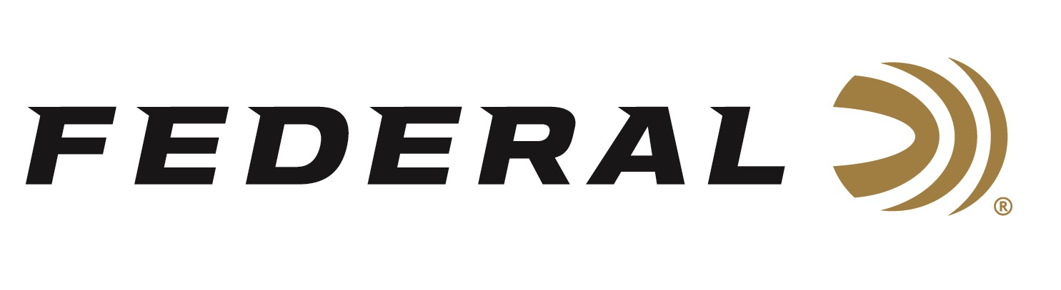

FOR IMMEDIATE RELEASE

7mm Backcountry Cartridge Won the NRA American Hunter Ammunition Product of the Year Award for 2026

ANOKA, Minnesota – April 17, 2026 – Federal’s 7mm Backcountry cartridge was awarded the 2026 Golden Bullseye Award from the NRA American Hunter publication for Ammunition Product of the Year. Federal Ammunition showcased the new cartridge at its booth (3403) during the 2026 NRA Annual Meetings & Exhibits, April 16-19, 2026, in Houston, Texas.
“We are proud and grateful that the NRA American Hunter publication recognized our innovative new cartridge with this prestigious award. More specifically, we thank the publication’s editors, Scott Olmsted, Jon Draper, and David Herman, for choosing it as this year’s winner,” said Federal’s Centerfire Ammunition Director, Mike Holm. “This endorsement speaks volumes for how the new 7mm Backcountry cartridge is such a true innovation. Our Peak Alloy case breaks the performance barrier of traditional brass cases, absolutely leveling up performance. We look forward to continued progression in what modern ammunition can do with the Peak Alloy case.”
Federal’s 7mm Backcountry is an all-new high-performance hunting cartridge boosted by all-new, patented one-piece, high-strength Peak Alloy case technology, which provides magnum performance in a standard bolt face rifle. Through 20-inch barrels and with 170-grain bullets, it can achieve 3,000 feet per second. The new cartridge is also intended for hunting with a suppressor, where shorter-barrel rifles are preferred.

Learn more at: Backcountry | Federal Premium.

The NRA Publications Golden Bullseye Awards acknowledge the finest products available for shooting sports. To qualify for consideration, a product must meet stringent criteria for design, function, value, and overall contribution to the shooting industry.

Federal Ammunition products are available at dealers nationwide and online. For more information on all Federal products and to sign up for notifications about new product availability, rebate promotions, and other brand news via email, visit www.federalpremium.com.

Pictured are Jesse Whiteside (left) and Mike Holm (right) from Federal Ammunition.

Press Release Contact: JJ Reich
Senior Manager – Press Relations
E-mail: media@tkghunt.com

About Federal Ammunition
Federal, headquartered in Anoka, MN, is an ammunition brand of The Kinetic Group, owned by CSG, a globally diversified industrial group based in Prague, Czech Republic. Since 1922, Federal has been a leader in ammunition innovation, delivering high-quality sporting and hunting products to shooters worldwide. With a commitment to conservation and the outdoor community, Federal continues to manufacture industry-leading ammunition that enhances the shooting experience while supporting outdoor traditions.

