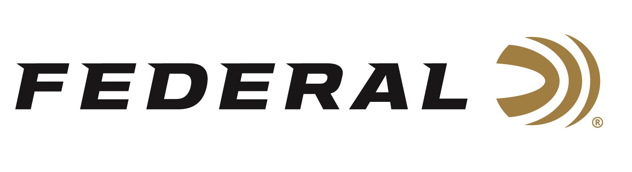

FOR IMMEDIATE RELEASE

Federal Ammunition Sponsored Shooter Vincent Hancock Received the 2026 Golden Bullseye Competitor Award

ANOKA, Minnesota – April 17, 2026 – Federal Ammunition congratulates Team Federal sponsored-shooter Vincent Hancock, who recently received the 2026 Golden Bullseye Competitor Award. This award, presented by Shooting Sports USA, recognizes Hancock for his historic achievements on the skeet field and his significant contributions to the sport through coaching and mentorship. Vincent recently accepted the award during the 2026 NRA Annual Meetings & Exhibits, April 16-19, 2026, in Houston, Texas.

Shooting Sports USA, the NRA’s digital hub for competitive shooters, named Hancock the recipient of the 2026 NRA Golden Bullseye Competitor Award, recognizing not just unmatched results, but a career built on making an impact and giving back. The four-time Olympic gold medalist remains one of the most accomplished skeet athletes in history, a standard-bearer in a sport where longevity is as difficult as winning.

“Federal Ammunition is extremely proud of the performances Hancock turns in all year long and year after year,” said Jason Nash, Federal’s V.P. of Marketing. “Vincent has an extremely impressive Olympic career, but the award reflects more than medals. It acknowledges his ongoing commitment to coaching and growing the next generation of competitive shooters, a role he has embraced while continuing to compete at the highest level. We are proud and grateful that he shoots for Team Federal.”

The NRA Publications Golden Bullseye Awards acknowledge the finest products available for shooting sports. To qualify for consideration, a product must meet stringent criteria for design, function, value, and overall contribution to the shooting industry.

Federal is the number one choice for shotgun shells. The company manufactures products in America for all competitive and recreational disciplines. See the full lineup, including Master Class and All-American target loads, at www.federalpremium.com.

Federal Ammunition products are available at dealers nationwide and online. For more information on all Federal products and to sign up for notifications about new product availability, rebate promotions, and other brand news via email, visit www.federalpremium.com.

Press Release Contact: JJ Reich
Senior Manager – Press Relations
E-mail: media@tkghunt.com

About Federal Ammunition
Federal, headquartered in Anoka, MN, is an ammunition brand of The Kinetic Group, owned by CSG, a globally diversified industrial group based in Prague, Czech Republic. Since 1922, Federal has been a leader in ammunition innovation, delivering high-quality sporting and hunting products to shooters worldwide. With a commitment to conservation and the outdoor community, Federal continues to manufacture industry-leading ammunition that enhances the shooting experience while supporting outdoor traditions.

