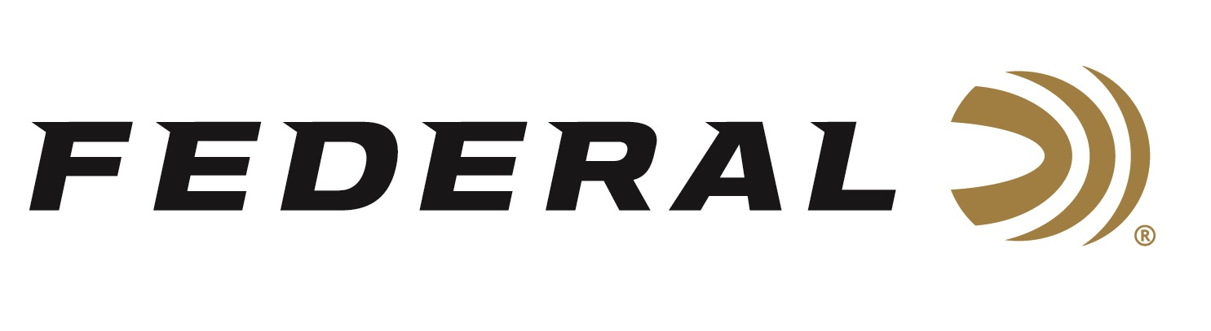
FOR IMMEDIATE RELEASE

Federal Ammunition is Proud to Sponsor NWTF’s 2026 Convention and Sport Show

ANOKA, Minnesota – February 6, 2026 – Federal Ammunition is the title sponsor of the Hunting Heritage Breakfast on Friday, February 13, at the National Wild Turkey Federation’s (NWTF) Annual Convention and Sport Show. The 2026 NWTF Convention will be held February 10-14, 2026, in Nashville, Tennessee. Federal Ammunition also continues as a Gobbler Sponsor of the overall event.

Federal Ammunition and the National Wild Turkey Federation have been working together for decades. The company has participated in every NWTF convention and hosted the Conservation Breakfast for 43 years. Federal Ammunition is one of the five longest-running sponsors of the NWTF.

“2026 marks the 50th anniversary of NWTF’s incredible convention and sport show, and it’s certainly something any turkey hunter will not want to miss,” said Federal's Community Relations Director, Jon Zinnel. “It’s great to see everyone come together to celebrate conservation successes and look to the future of wild turkey conservation and all things hunting. It’s the perfect platform for highlighting our product offerings, especially our new turkey loads for 2026.”

Federal's turkey shotshells offer performance in a wide variety of options. Their current product families include Federal Premium Grand Slam, 3rd Degree with TSS, HEAVYWEIGHT TSS, and Custom Shop TSS turkey loads. New for 2026, Realtree 40th Anniversary Special Edition and Rob Roberts Limited Edition turkey loads.

This year, Federal is helping Realtree celebrate four decades of camouflage design and innovation with five turkey loads in commemorative packaging. Two Grand Slam lead loads are 3-inch, 12-gauge, and 20-gauge in No. 5 shot. The Realtree 40th Anniversary Special Edition comprises three Heavyweight TSS loads: 3-inch, 12-gauge, 20-gauge, and 410-bore in No. 9 shot.

Rob Roberts Limited Edition turkey loads are heavy-payload shotshells designed in
collaboration with legendary choke designer Rob Roberts Custom Gunworks. The new loads are Heavyweight TSS in 3-inch, 12-gauge, 2-ounce. in No. 7 or 9 shot, and 3-inch, 20-gauge. 1-5/8-ounce. in No. 7 or 9 shot.

Attendees of the NWTF’s 2025 Convention and Sport Show are encouraged to stop by Federal’s booth No. 1113 to talk with Federal’s enthusiastic staff about the perfect ammunition for any upcoming turkey hunting adventure.

To learn more about this new product and all the new ammunition from Federal Ammunition for 2026, visit New Products | Federal Premium.

Federal Ammunition products are available at dealers nationwide and online. For more information on all Federal products and to sign up for notifications about new product availability, rebate promotions, and other brand news via email, visit www.federalpremium.com.

Press Release Contact: JJ Reich
Senior Manager – Press Relations
E-mail: media@tkghunt.com

About Federal Ammunition
Federal, headquartered in Anoka, MN, is an ammunition brand of The Kinetic Group, owned by CSG, a globally diversified industrial group based in Prague, Czech Republic. Since 1922, Federal has been a leader in ammunition innovation, delivering high-quality sporting and hunting products to shooters worldwide. With a commitment to conservation and the outdoor community, Federal continues to manufacture industry-leading ammunition that enhances the shooting experience while supporting outdoor traditions.

