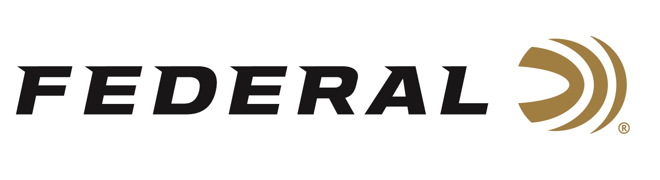

FOR IMMEDIATE RELEASE

Federal New All-American 20-Gauge Target Loads Now Shipping

ANOKA, Minnesota – April 6, 2026 – Federal Ammunition expands its all-new All-American shotshell product line. These competition-level trap and skeet loads feature a customized Podium wad that extracts peak performance from utilizing Federal’s straight-wall hull, reliable primers, high-antimony lead shot, and select propellant. Two new-for-2026, 20-gauge loads are now shipping to dealers nationwide.

All-American

“All-American features a one-piece Podium wad and high-antimony lead shot that balances hardness and density,” said Federal’s Shotshell Product Manager, Sam Oftedahl. “The loads are constructed with a straight-wall hull, an inserted plastic base wad, and a striated tube for optimum performance. Shooters who prefer to shoot 20-gauge are sure to love the high-performance of these quality loads.”

All-American offers a much better option than standard target loads for competitors in trap and skeet. They feature high-quality components in an ultra-reliable two-piece straight wall hull design. All-American is offered in the most popular payloads and velocities for modern trap and skeet competitions and is packaged in 25-count boxes.

Part No. / Description / MSRP
FAA20 7.5 / All American, 20 Gauge, 7.5 Shot, 2-3/4 in, 7/8 oz, 1200 fps / $15.99
FAA20 8 / All American, 20 Gauge, 8 Shot, 2-3/4 in, 7/8 oz, 1200 fps / $15.99

Federal Ammunition products are available at dealers nationwide and online. For more information on all Federal products and to sign up for notifications about new product availability, rebate promotions, and other brand news via email, visit www.federalpremium.com.

Press Release Contact: JJ Reich
Senior Manager – Press Relations
E-mail: media@tkghunt.com

About Federal Ammunition
Federal, headquartered in Anoka, MN, is an ammunition brand of The Kinetic Group, owned by CSG, a globally diversified industrial group based in Prague, Czech Republic. Since 1922, Federal has been a leader in ammunition innovation, delivering high-quality sporting and hunting products to shooters worldwide. With a commitment to conservation and the outdoor community, Federal continues to manufacture industry-leading ammunition that enhances the shooting experience while supporting outdoor traditions.

