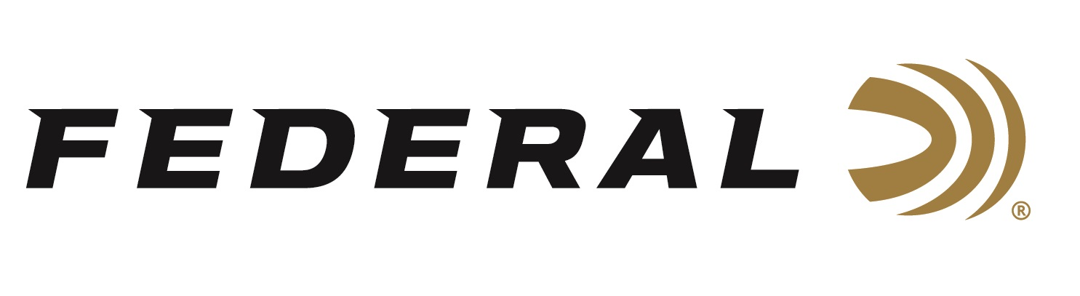

FOR IMMEDIATE RELEASE

Federal’s Protect & Save Personal Defense Ammo Rebate Program is Underway

ANOKA, Minnesota – July 13, 2026 – Federal Ammunition has launched its summertime Protect & Save rebate, allowing consumers to save on select Federal Premium® Personal Defense handgun ammunition through August 31, 2026. Qualifying handgun products include HST, Hydra-Shok, Hydra-Shok Deep, Practice & Defend HST, HST Micro, and Hydra-Shok Low Recoil.

To take advantage of the rebate, customers must purchase at least two boxes of qualifying Federal Premium Personal Defense handgun ammunition between July 1 and August 31, 2026. Eligible purchases qualify for a rebate of 20 percent of the purchase price, excluding taxes, fees, shipping, and handling charges. The maximum rebate is $200 per person or household. Rebate submissions must be received by September 30, 2026.

Hydra-Shok has been trusted for self-defense since 1989. Hydra-Shok Deep builds on that time-tested platform with design improvements to meet modern performance measurements. The bullet features a more robust center post and a core design that penetrates to optimal depths through the barriers most commonly encountered in self-defense situations.

HST is the duty load of choice for law enforcement officers throughout the world. Its specially designed hollow point won't plug while passing through a variety of barriers, and the bullet jacket and core hold together to provide nearly 100 percent weight retention through even the toughest materials.

For complete details on rebates, visit: https://www.federalpremium.com/this-is-federal/rebates-and-promotions.html.

To learn more about this new product and all the new ammunition from Federal Ammunition for 2026, visit New Products | Federal Premium.

Federal Ammunition products are available at dealers nationwide and online. For more information on all Federal products and to sign up for notifications about new product availability, rebate promotions, and other brand news via email, visit www.federalpremium.com.

Press Release Contact: JJ Reich
Senior Manager – Press Relations
E-mail: media@tkghunt.com

About Federal Ammunition
Federal, headquartered in Anoka, MN, is an ammunition brand of The Kinetic Group, owned by CSG, a globally diversified industrial group based in Prague, Czech Republic. Since 1922, Federal has been a leader in ammunition innovation, delivering high-quality sporting and hunting products to shooters worldwide. With a commitment to conservation and the outdoor community, Federal continues to manufacture industry-leading ammunition that enhances the shooting experience while supporting outdoor traditions.

