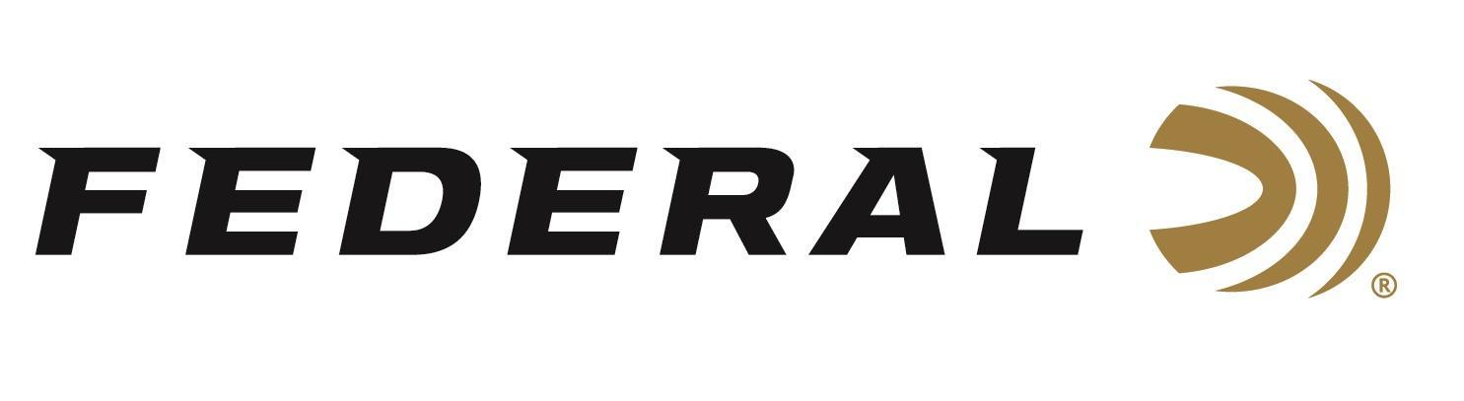

FOR IMMEDIATE RELEASE
Federal Realtree 40th Anniversary Ammunition Now Shipping
ANOKA, Minnesota – February 20, 2026 – Federal Ammunition has officially begun shipping its Federal Realtree 40th Anniversary ammunition, commemorating four decades of Realtree’s iconic camouflage patterns with a special limited-run version of Federal Premium® HEAVYWEIGHT TSS and Grand Slam turkey loads.
Realtree Limited Edition
“Realtree has played a major role in modern turkey hunting for 40 years, and this ammunition is a fitting way to celebrate that legacy,” said Federal’s Shotshell Product Line Director Dan Compton. “By pairing our proven HEAVYWEIGHT TSS and Grand Slam turkey loads with Realtree’s camouflage, we’re giving turkey hunters a commemorative option that delivers the excellent performance they rely on in the field. Plus, the Realtree 40th Anniversary Edition packaging just looks cool.”
HEAVYWEIGHT TSS shotshells feature Tungsten Super Shot payloads that provide the highest pellet counts possible. At 18 g/cc, the tungsten-alloy is 56 percent denser than lead for the most energy and highest velocities at extreme range. Its rear-braking FLITECONTROL FLEX wad performs flawlessly through both ported and standard turkey chokes, delivering the most consistent, deadly patterns possible. The limited-run packaging features Realtree Legacy camouflage.
Grand Slam shotshells feature Federal’s FLITECONTROL FLEX wad system, which works in both standard and ported turkey chokes, opening from the rear to deliver controlled payload release and extremely consistent patterns. The high-quality copper-plated lead pellets are cushioned with an advanced buffering compound to provide dense shot strings and ample energy to crush gobblers. The limited-run packaging features Realtree Original camouflage.
Part No. / Description / MSRP
PFCX157FRT 5 / Realtree Grand Slam 12-gauge No. 5, 10-count / $27.99
PFCX258FRT 5 / Realtree Grand Slam 20-gauge No. 5, 10-count / $23.99
PTSSX193FRT 9 / Realtree HEAVYWEIGHT TSS 12-gauge No. 9, 5-count / $93.99
PTSSX259FRT 9 / Realtree HEAVYWEIGHT TSS 20-gauge No. 9, 5-count / $81.99
PTSS419FRT 9 / Realtree HEAVYWEIGHT TSS 410-Bore No. 9, 5-count / $61.99

Federal Ammunition products are available at dealers nationwide and online. For more information on all Federal products and to sign up to receive notifications about new product availability, rebate promotions, and other brand news via email, visit www.federalpremium.com.

Press Release Contact: JJ Reich
Senior Manager – Press Relations
E-mail: media@tkghunt.com

About Federal Ammunition
Federal, headquartered in Anoka, MN, is an ammunition brand of The Kinetic Group, owned by CSG, a globally diversified industrial group based in Prague, Czech Republic. Since 1922, Federal has been a leader in ammunition innovation, delivering high-quality sporting and hunting products to shooters worldwide. With a commitment to conservation and the outdoor community, Federal continues to manufacture industry-leading ammunition that enhances the shooting experience while supporting outdoor traditions.

