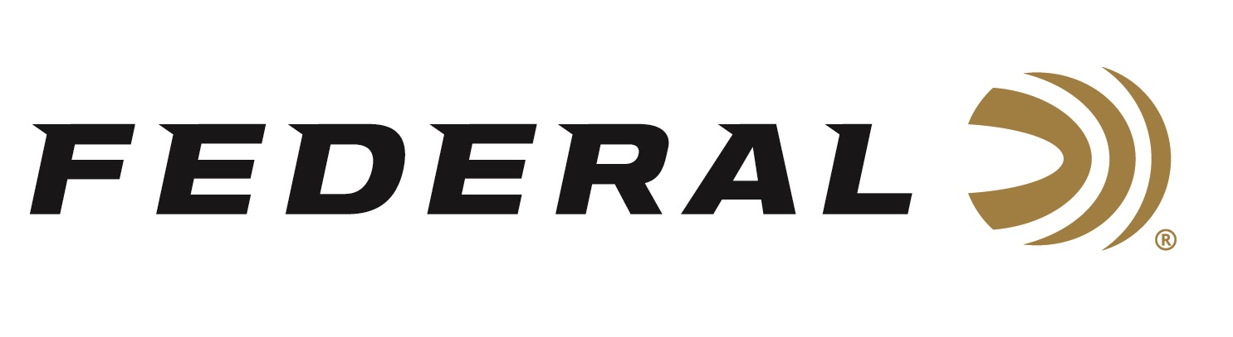

FOR IMMEDIATE RELEASE

Federal’s Spring Savings Slam Turkey Load Rebate Program is Underway

ANOKA, Minnesota – March 2, 2026 – Federal Ammunition's Spring Savings Slam rebate for hunting springtime gobblers is underway, and the promotion will run until May 31, 2026. Wild turkey hunters can now buy Federal Premium turkey loads and get up to $100 back.

To take advantage of this rebate, customers must purchase Federal’s Strut-Shok to receive a $3.00 rebate per box or buy Federal Premium® Grand Slam, 3rd Degree, Grand Slam Realtree 40th Anniversary Edition, HEAVYWEIGHT TSS Realtree 40th Anniversary Edition, HEAVYWEIGHT TSS Rob Roberts Limited Edition, HEAVYWEIGHT TSS to receive $5 per box back.

A minimum purchase of two (2) boxes is required, with a maximum rebate of $100.00 per person or household. Valid purchases must be made from March 1 through May 31, 2025. The deadline for submission of this rebate offer is June 30, 2026.

Federal's turkey shotshells offer performance in a wide variety of options. Their current product families include Federal Premium Grand Slam, 3rd Degree with TSS, HEAVYWEIGHT TSS, and more. New for 2026, Federal partnered with Realtree to launch a commemorative 40th Anniversary Special Edition of turkey loads and collaborated with Rob Roberts on Limited Edition line of turkey offerings.

Federal is helping Realtree celebrate four decades of camouflage design and innovation with five turkey loads in commemorative packaging. Two Grand Slam lead loads are 3-inch, 12-gauge, and 20-gauge in No. 5 shot. The Realtree 40th Anniversary Special Edition comprises three Heavyweight TSS loads: 3-inch, 12-gauge, 20-gauge, and 410-bore in No. 9 shot.

Rob Roberts Limited Edition turkey loads are heavy-payload shotshells designed in
collaboration with legendary choke designer Rob Roberts Custom Gunworks. The new loads are Heavyweight TSS in 3-inch, 12-gauge, 2-ounce. in No. 7 or 9 shot, and 3-inch, 20-gauge. 1-5/8-ounce. in No. 7 or 9 shot.

For complete details on rebates, visit: https://www.federalpremium.com/this-is-federal/rebates-and-promotions.html.
To learn more about this new product and all the new ammunition from Federal Ammunition for 2026, visit New Products | Federal Premium.

Federal Ammunition products are available at dealers nationwide and online. For more information on all Federal products and to sign up for notifications about new product availability, rebate promotions, and other brand news via email, visit www.federalpremium.com.

Press Release Contact: JJ Reich
Senior Manager – Press Relations
E-mail: media@tkghunt.com

About Federal Ammunition
Federal, headquartered in Anoka, MN, is an ammunition brand of The Kinetic Group, owned by CSG, a globally diversified industrial group based in Prague, Czech Republic. Since 1922, Federal has been a leader in ammunition innovation, delivering high-quality sporting and hunting products to shooters worldwide. With a commitment to conservation and the outdoor community, Federal continues to manufacture industry-leading ammunition that enhances the shooting experience while supporting outdoor traditions.

